# การวิเคราะห์การใช้ไฟฟ้า

รายงานนี้ประกอบด้วยการวิเคราะห์พฤติกรรมการใช้ไฟฟ้าและการติดตั้งโซล่าเซลล์.

## Images from Result

Image: anual_load.png

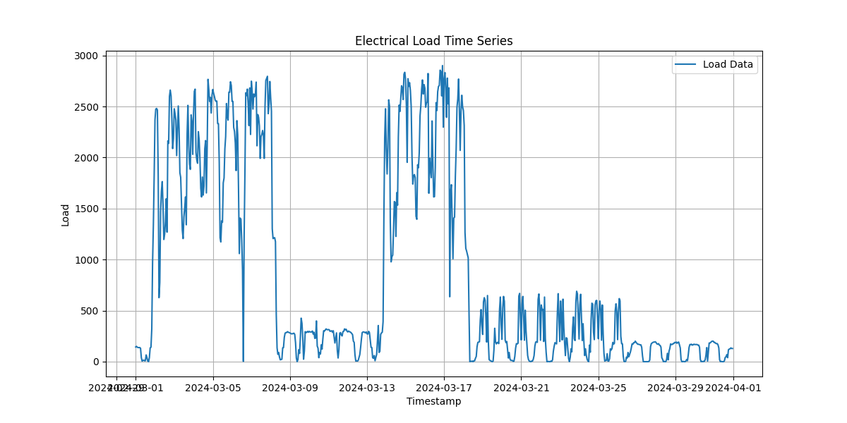

Image: average_load_every_day.png

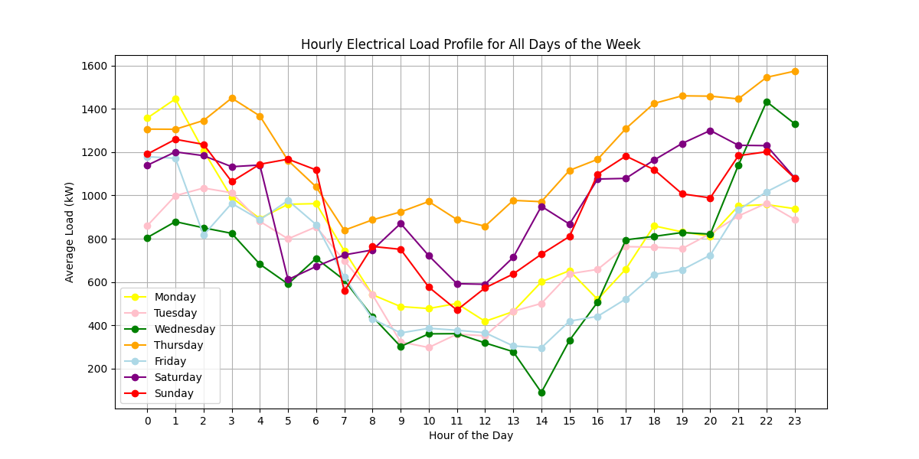

Image: average_weekday_weekend.png

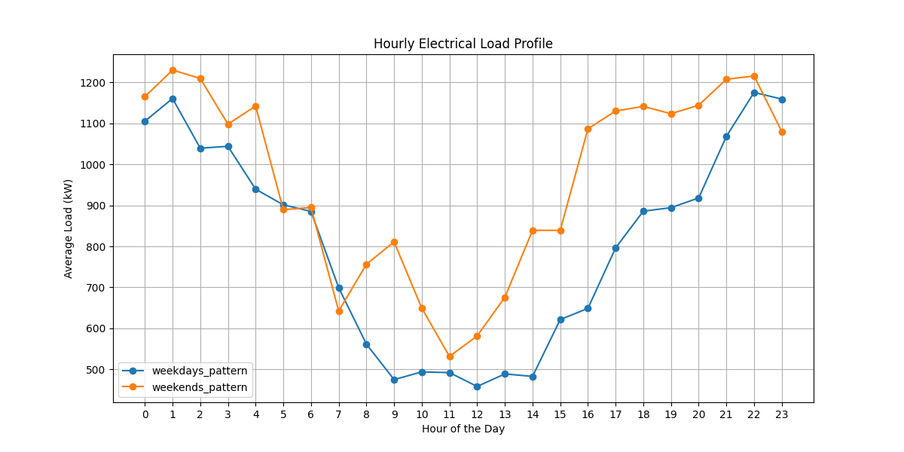

Image: LoadVariation.png

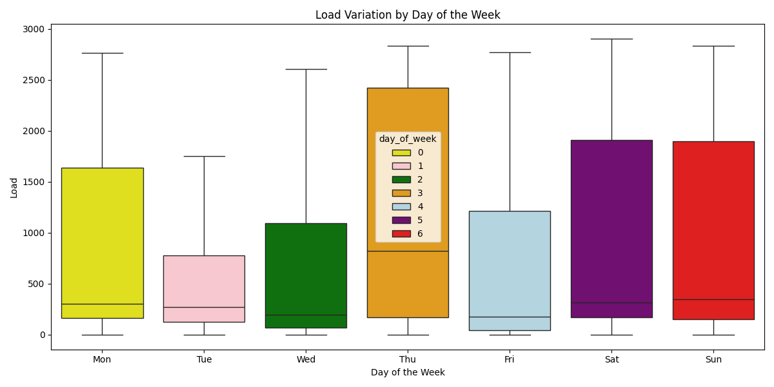

Image: Load_and_PV(1,000_kWp)_10_October.png

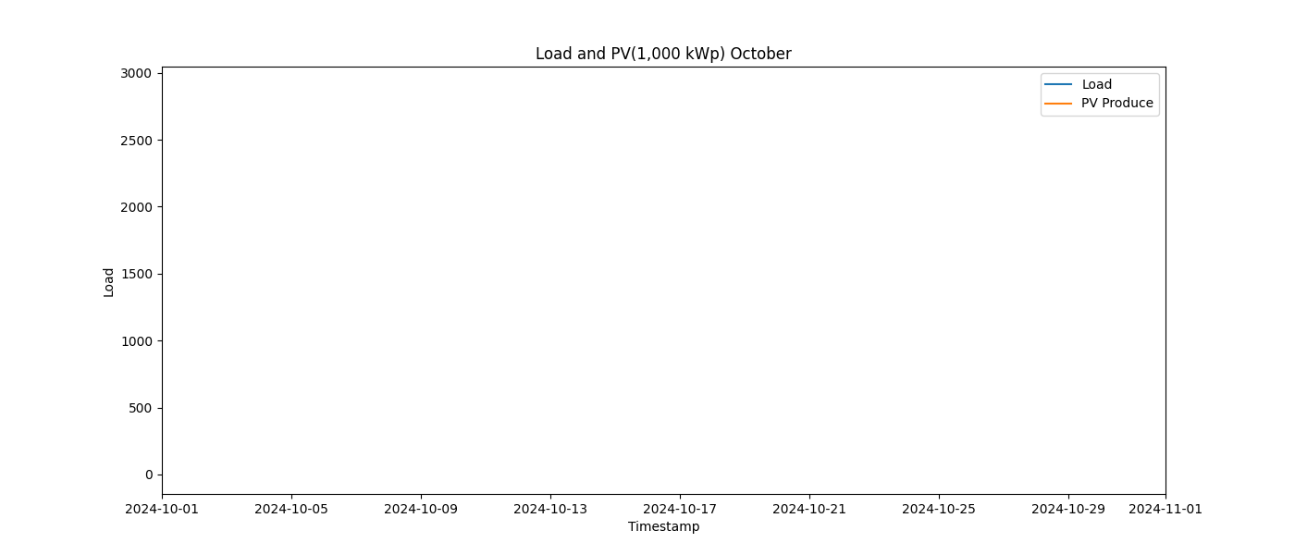

Image: Load_and_PV(1,000_kWp)_11_November.png

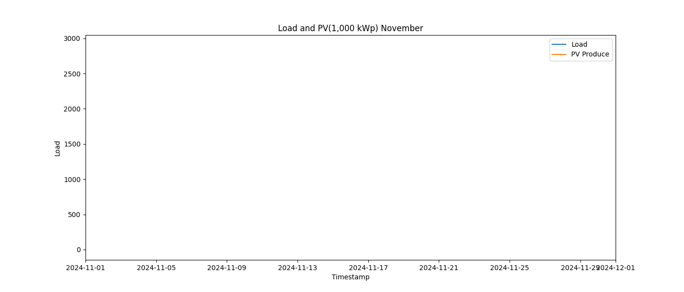

Image: Load_and_PV(1,000_kWp)_12_December.png

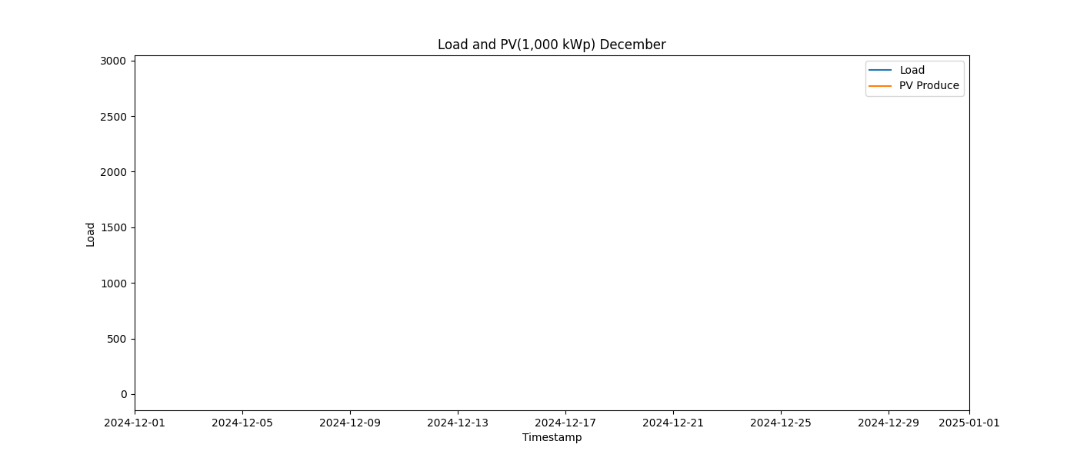

Image: Load_and_PV(1,000_kWp)_1_January.png

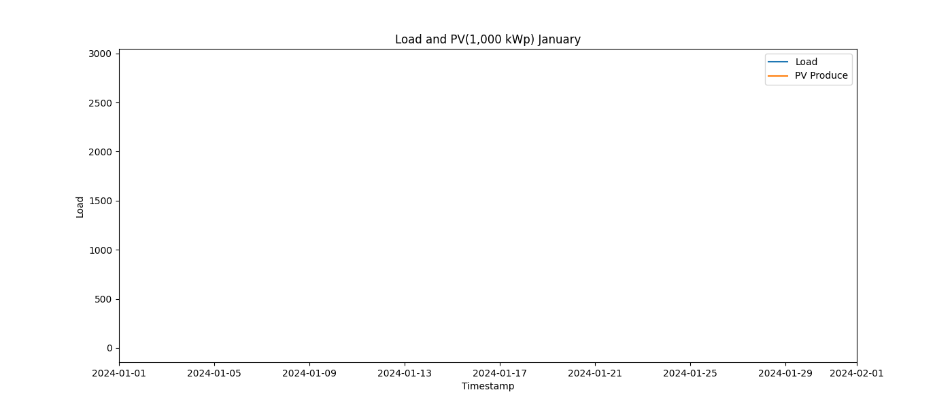

Image: Load_and_PV(1,000_kWp)_2_February.png

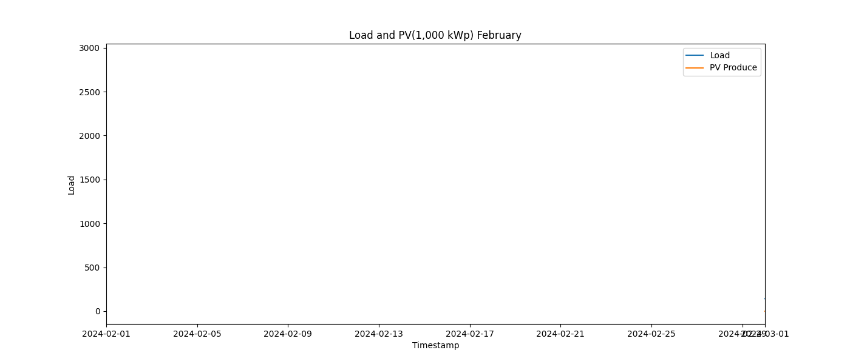

Image: Load_and_PV(1,000_kWp)_3_March.png

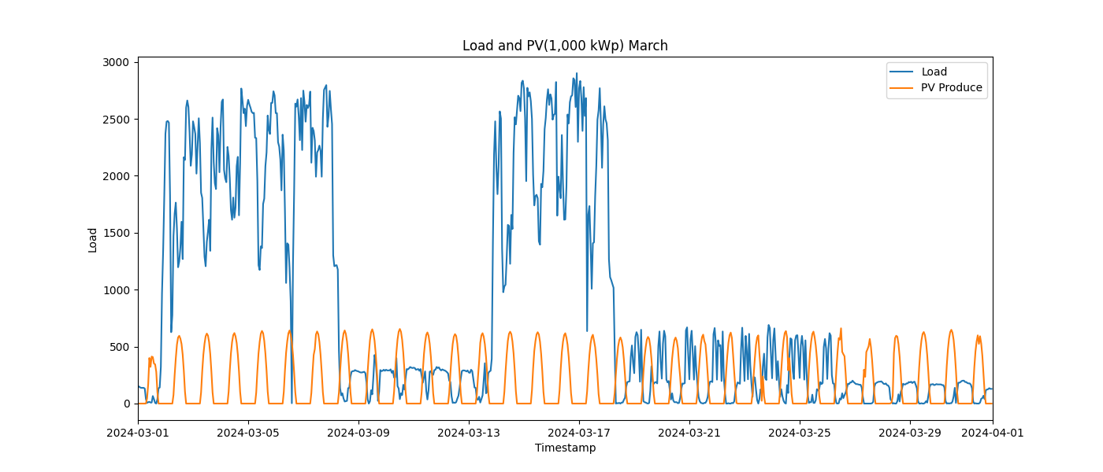

Image: Load_and_PV(1,000_kWp)_4_April.png

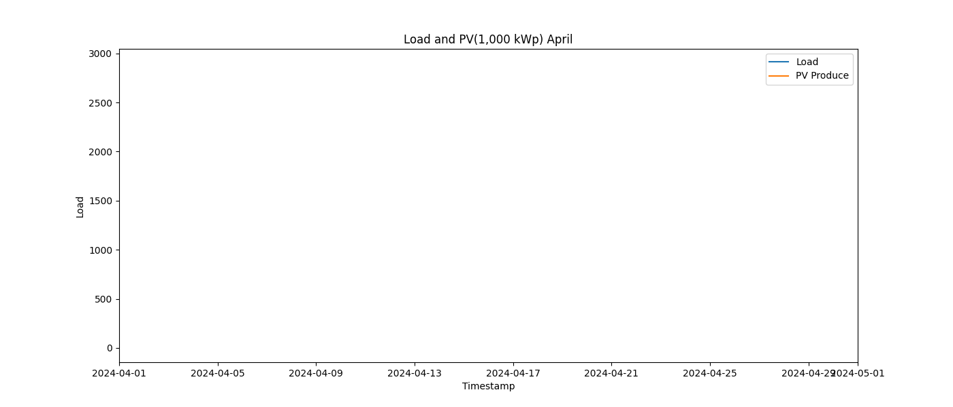

Image: Load_and_PV(1,000_kWp)_5_May.png

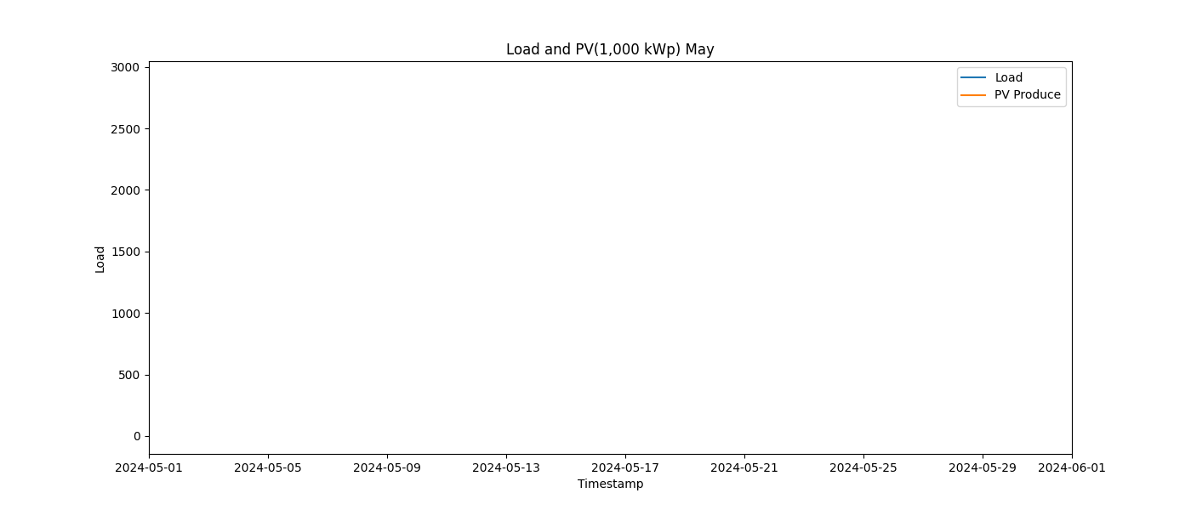

Image: Load_and_PV(1,000_kWp)_6_June.png

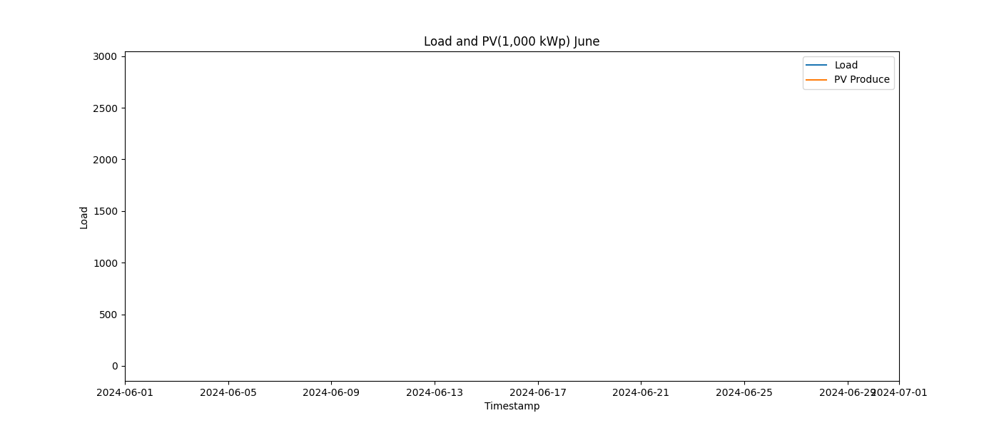

Image: Load_and_PV(1,000_kWp)_7_July.png

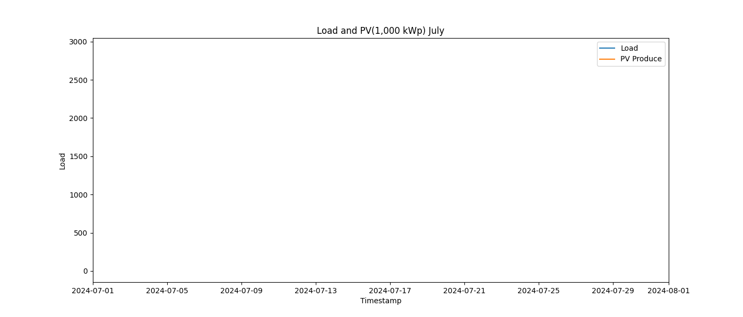

Image: Load_and_PV(1,000_kWp)_8_August.png

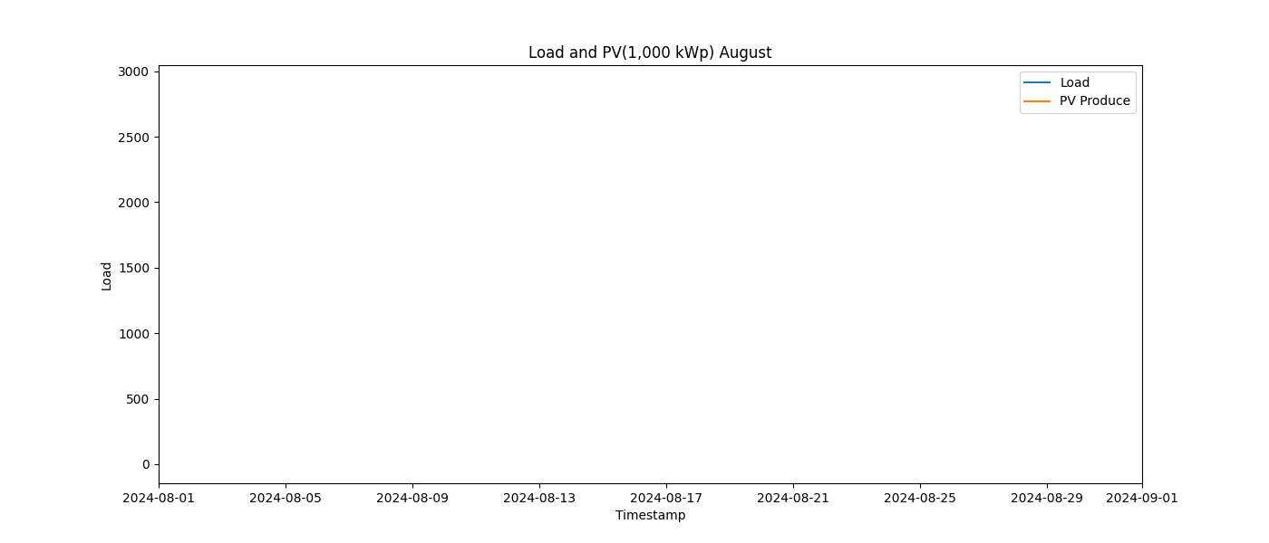

Image: Load_and_PV(1,000_kWp)_9_September.png

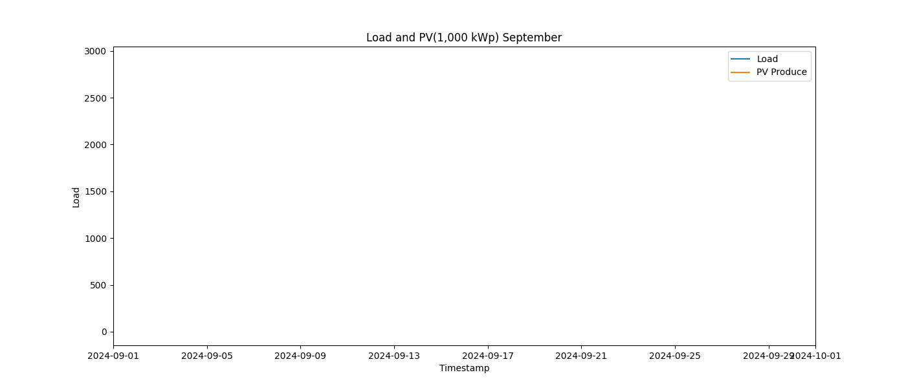

Image: Load_and_PV(100_kWp)_10_October.png

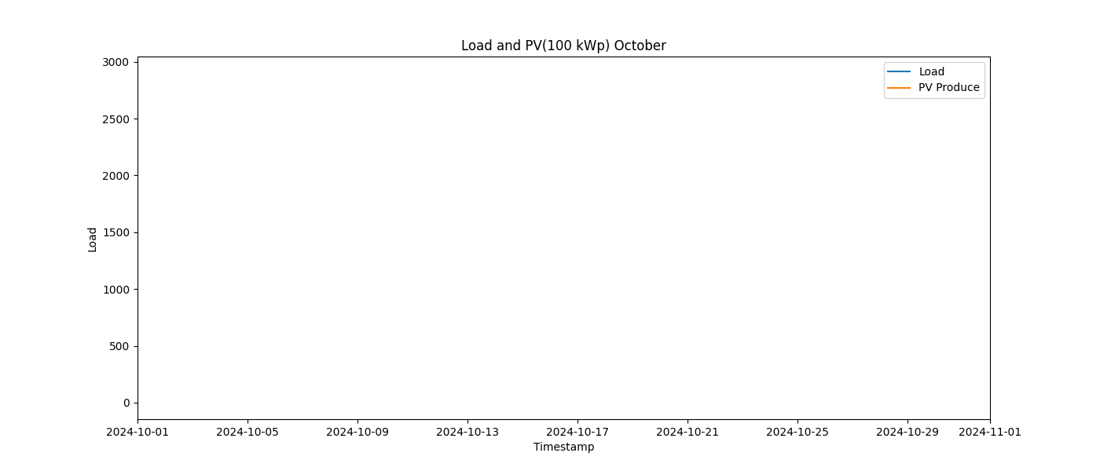

Image: Load_and_PV(100_kWp)_11_November.png

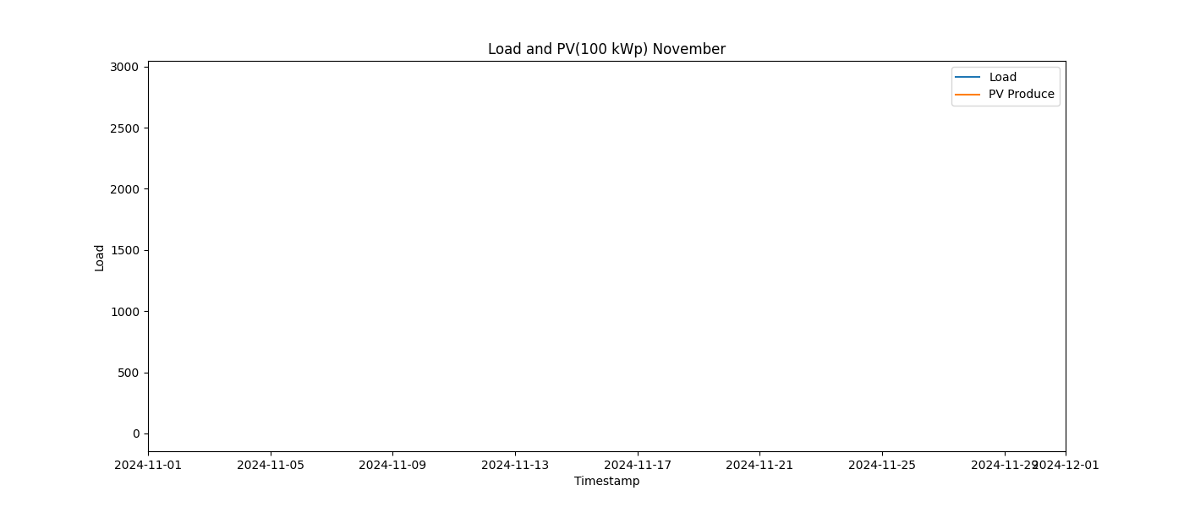

Image: Load_and_PV(100_kWp)_12_December.png

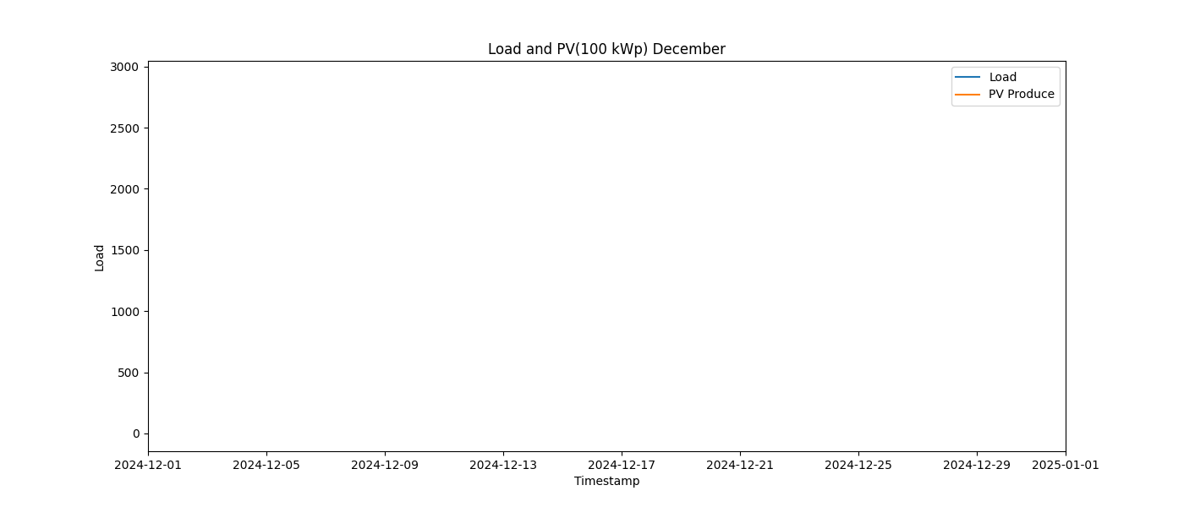

Image: Load_and_PV(100_kWp)_1_January.png

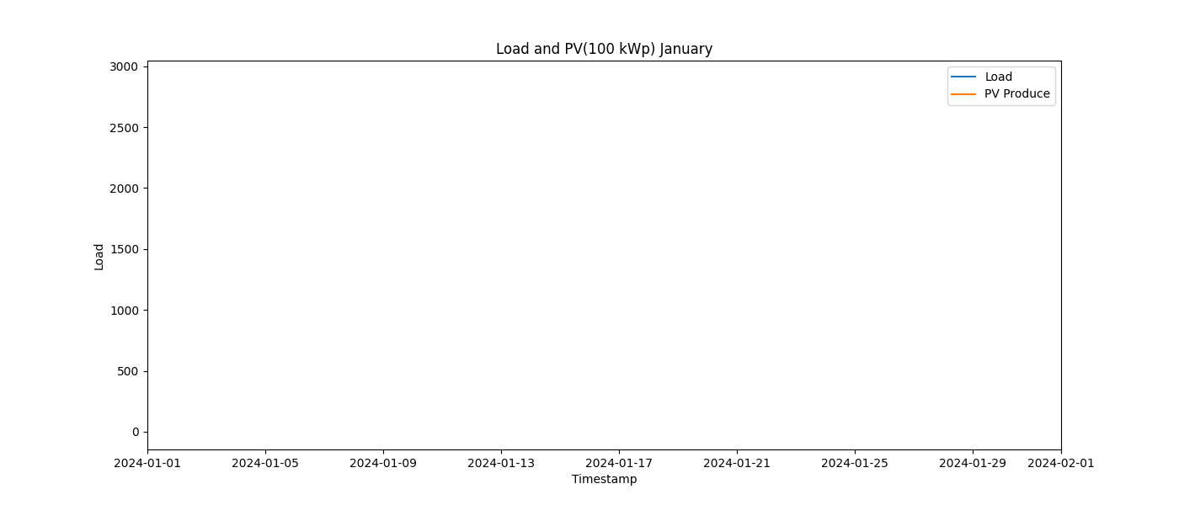

Image: Load_and_PV(100_kWp)_2_February.png

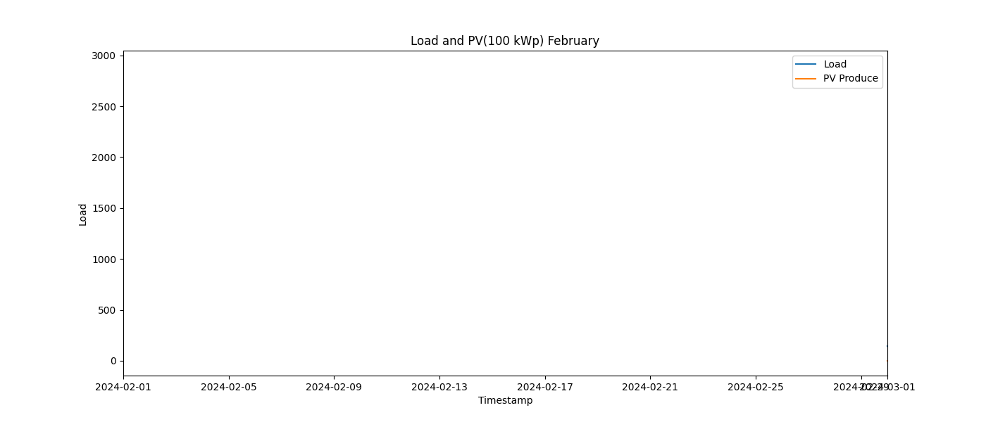

Image: Load_and_PV(100_kWp)_3_March.png

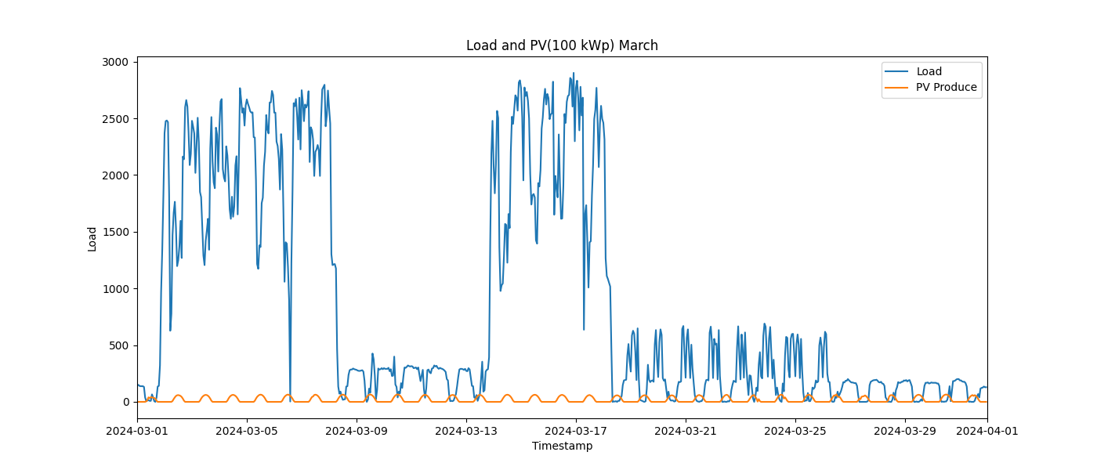

Image: Load_and_PV(100_kWp)_4_April.png

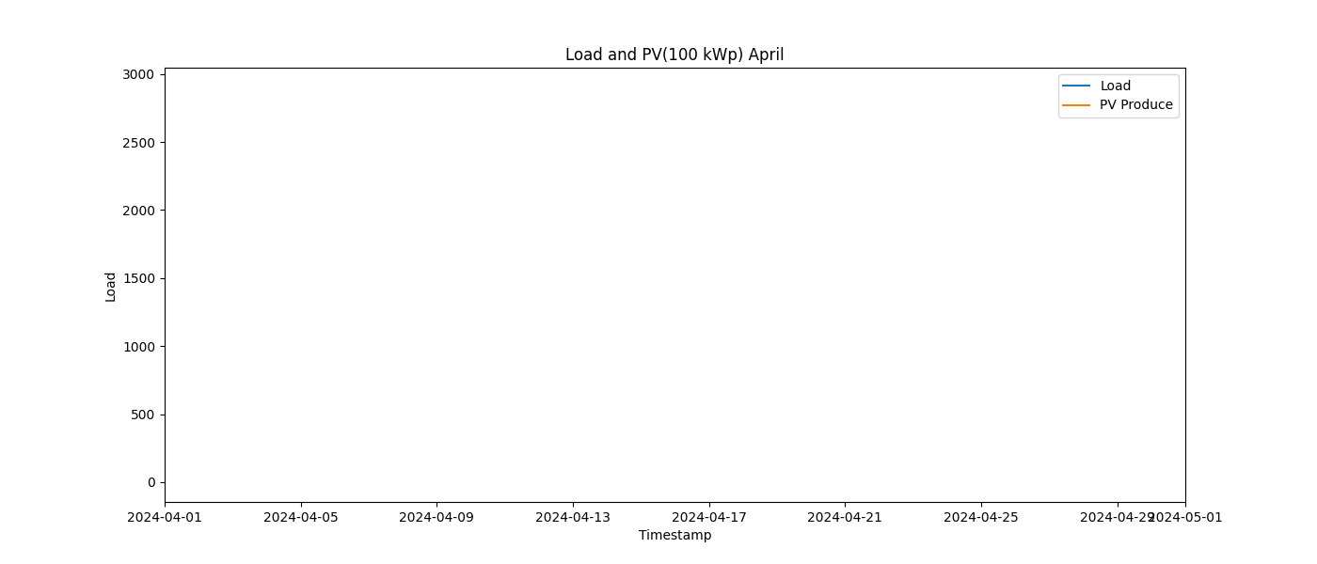

Image: Load_and_PV(100_kWp)_5_May.png

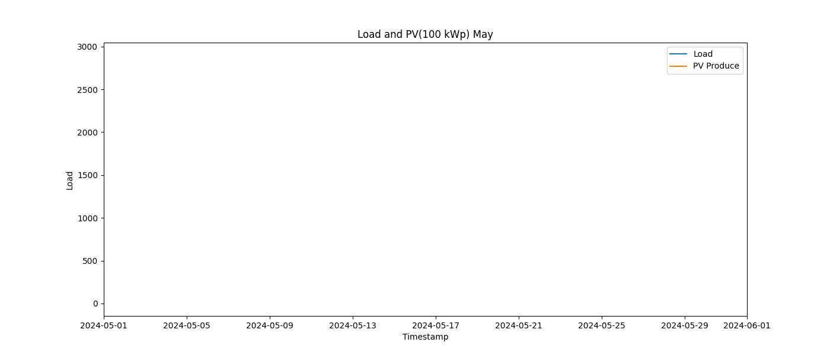

Image: Load_and_PV(100_kWp)_6_June.png

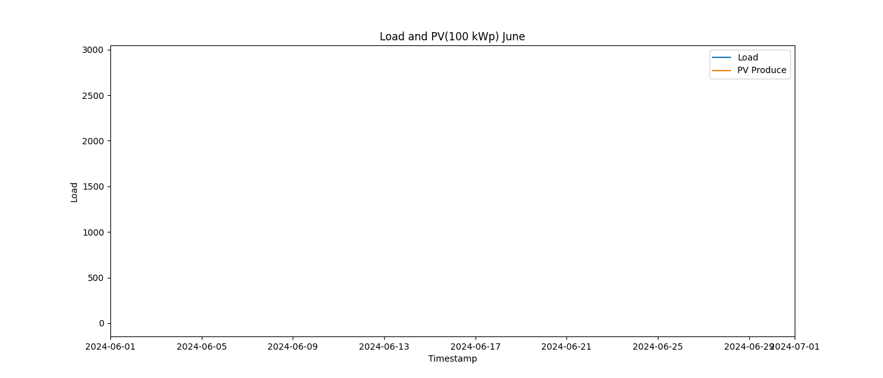

Image: Load_and_PV(100_kWp)_7_July.png

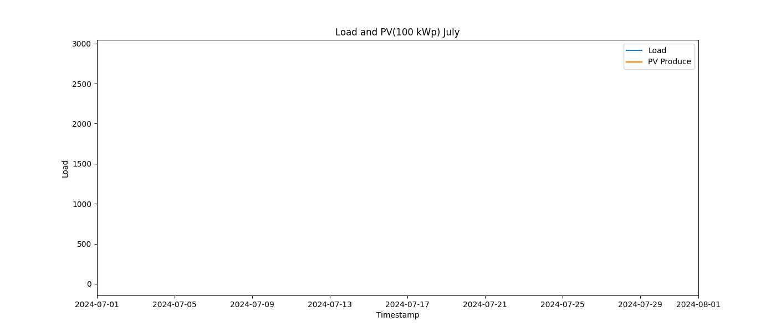

Image: Load_and_PV(100_kWp)_8_August.png

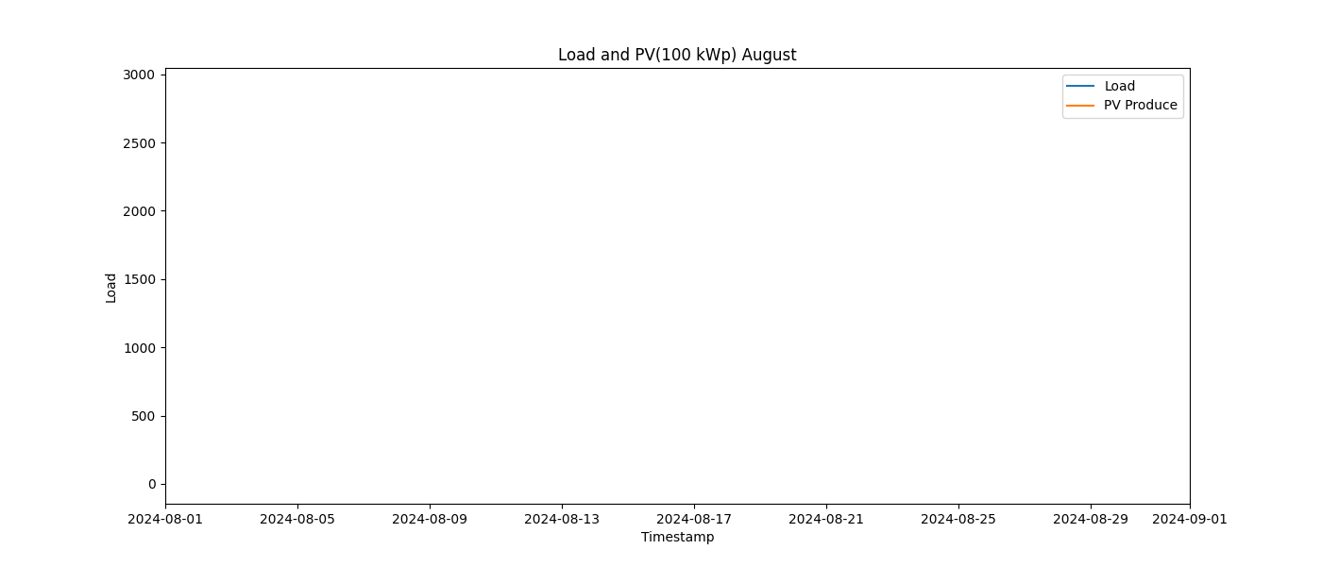

Image: Load_and_PV(100_kWp)_9_September.png

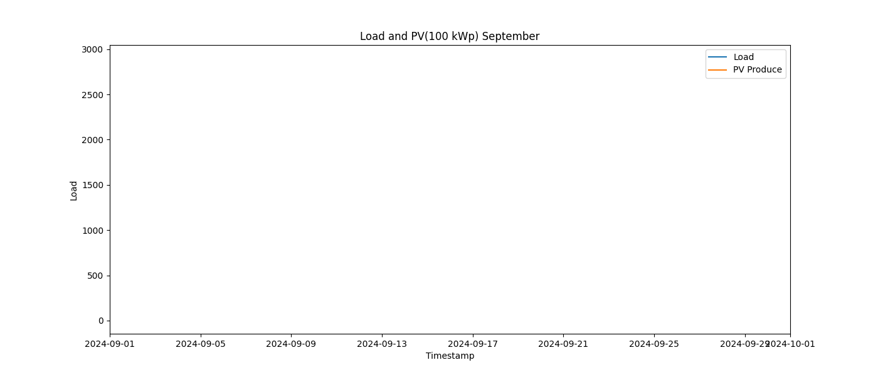

Image: Load_and_PV(500_kWp)_10_October.png

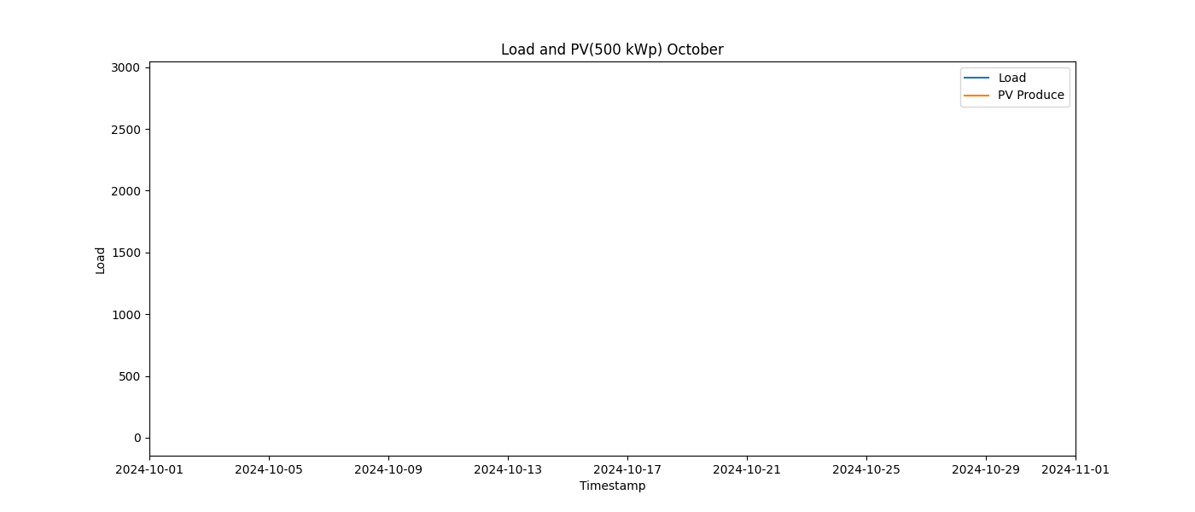

Image: Load_and_PV(500_kWp)_11_November.png

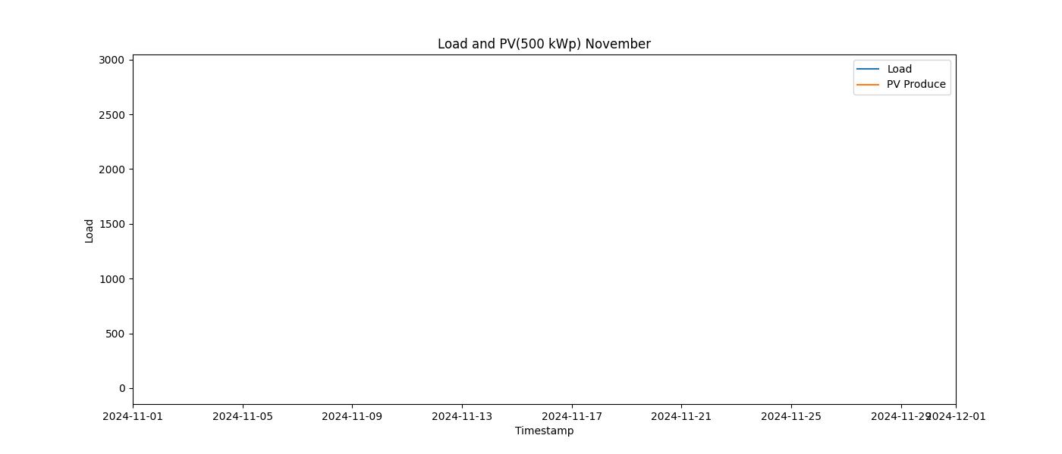

Image: Load_and_PV(500_kWp)_12_December.png

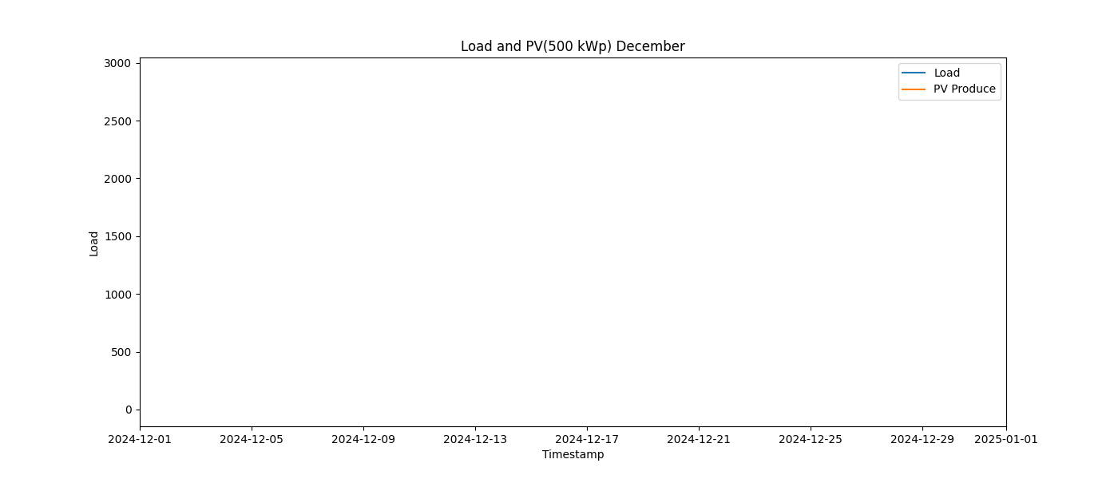

Image: Load_and_PV(500_kWp)_1_January.png

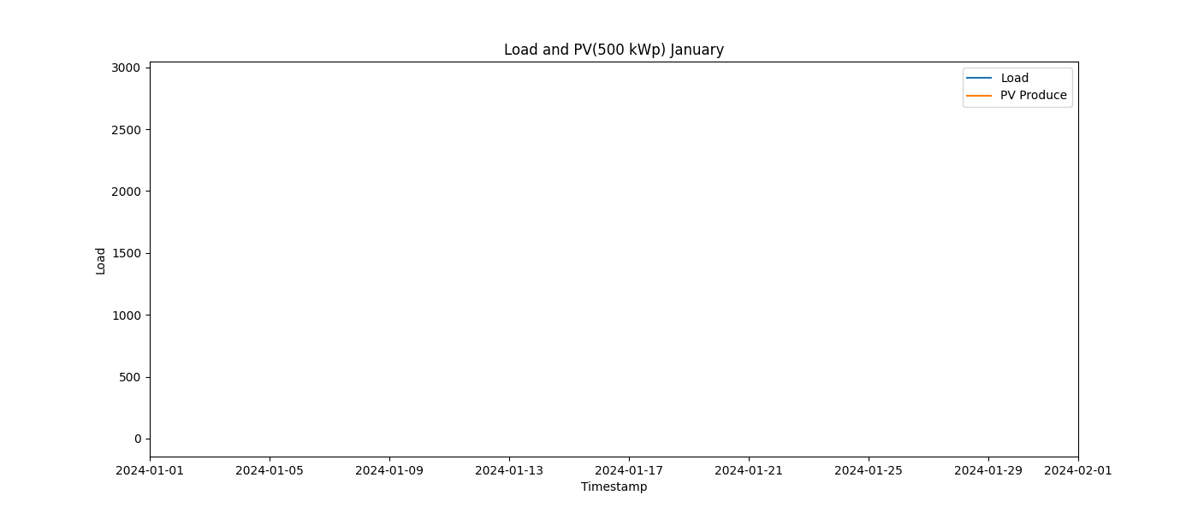

Image: Load_and_PV(500_kWp)_2_February.png

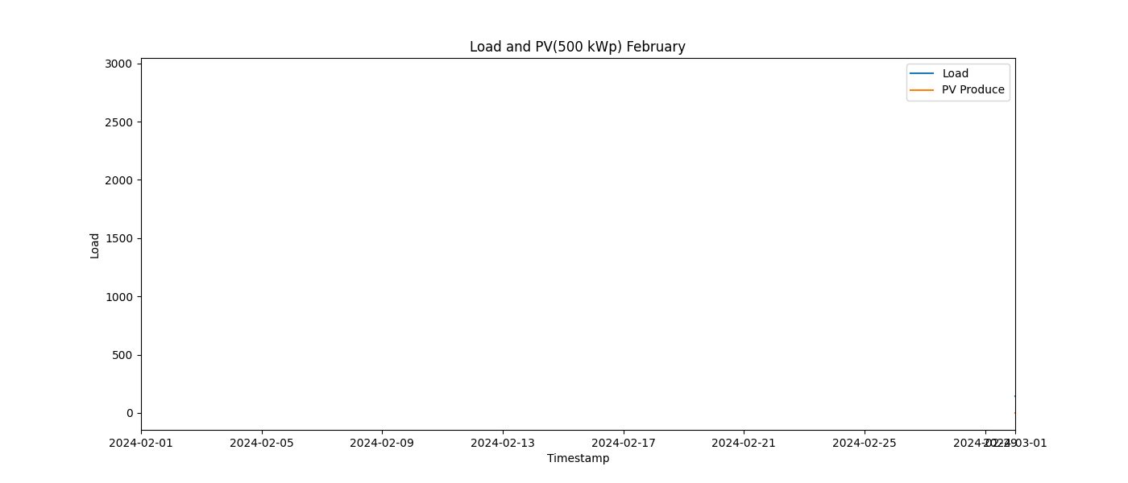

Image: Load_and_PV(500_kWp)_3_March.png

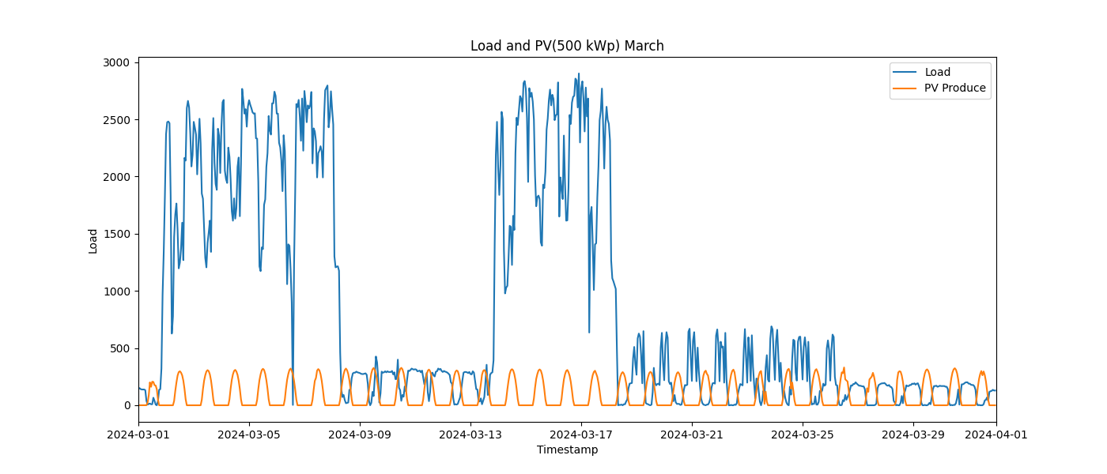

Image: Load_and_PV(500_kWp)_4_April.png

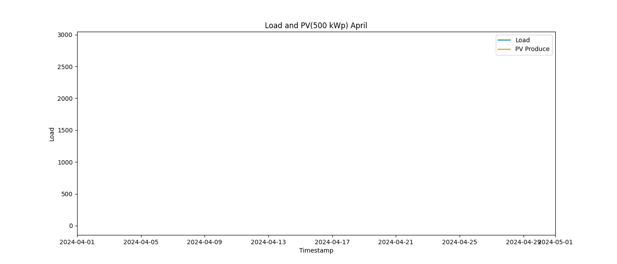

Image: Load_and_PV(500_kWp)_5_May.png

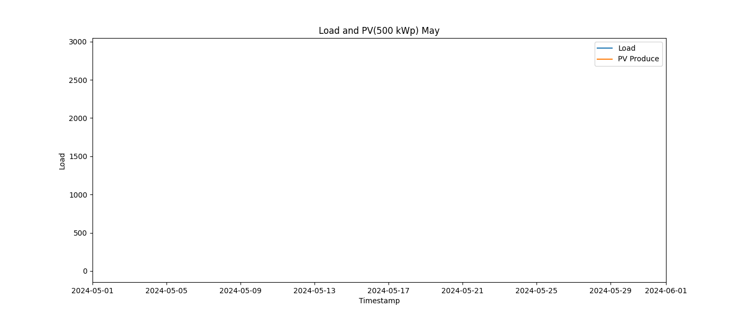

Image: Load_and_PV(500_kWp)_6_June.png

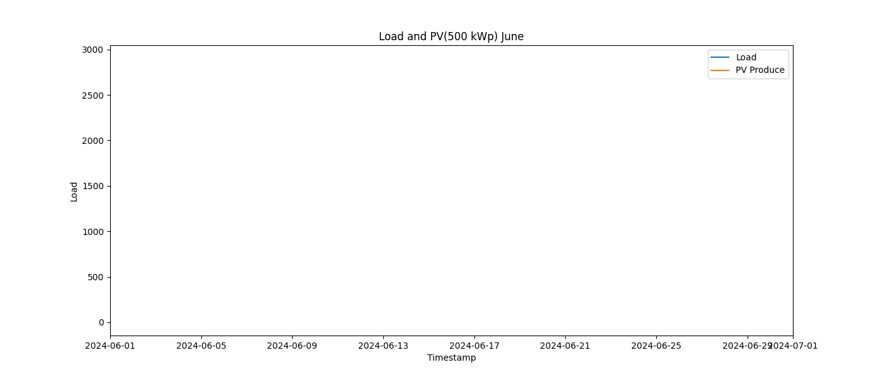

Image: Load_and_PV(500_kWp)_7_July.png

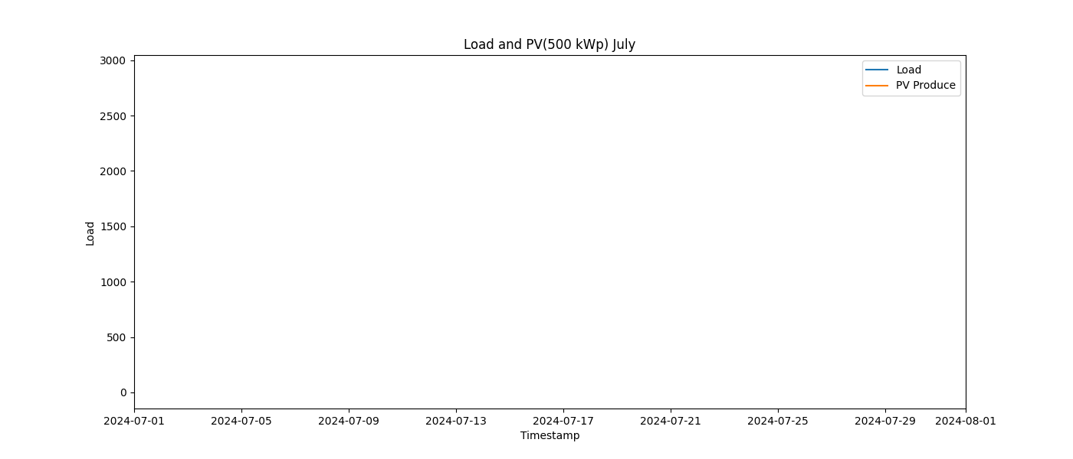

Image: Load_and_PV(500_kWp)_8_August.png

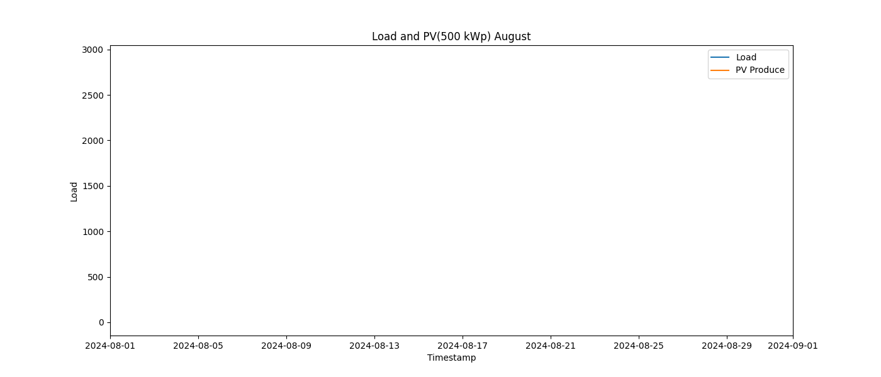

Image: Load_and_PV(500_kWp)_9_September.png

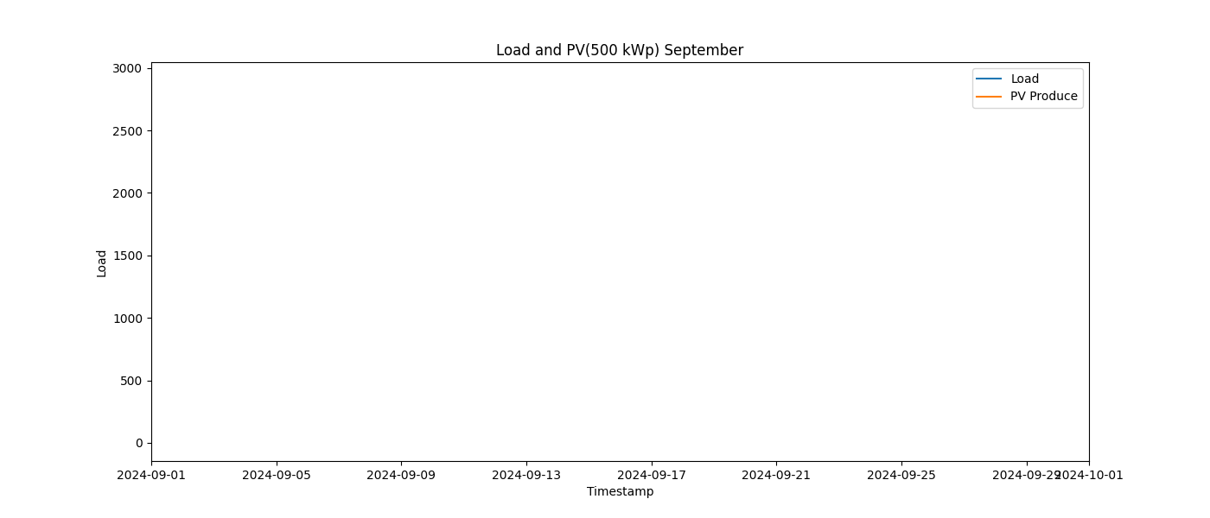

Image: load_distribution.png

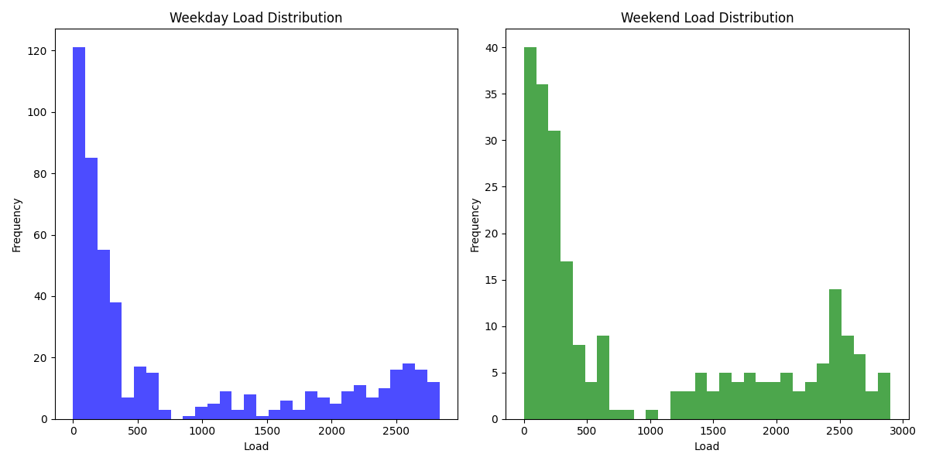

Image: load_duration_curve_all_days.png

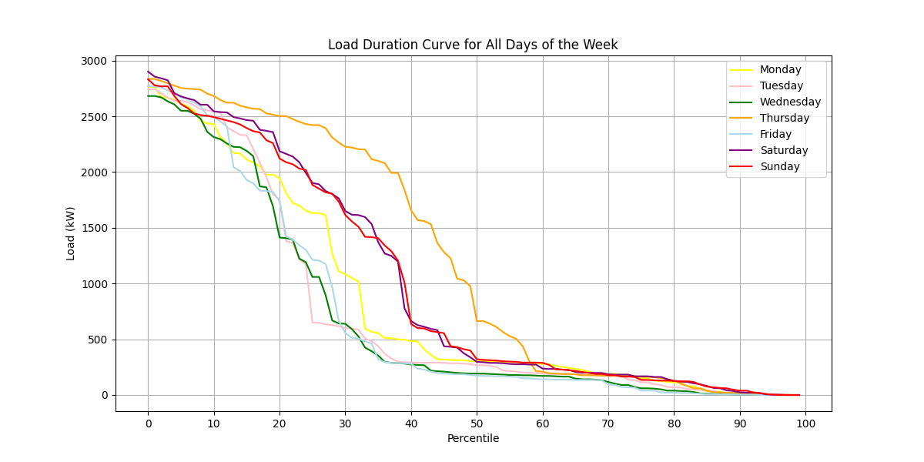

Image: load_duration_curve_all_months.png

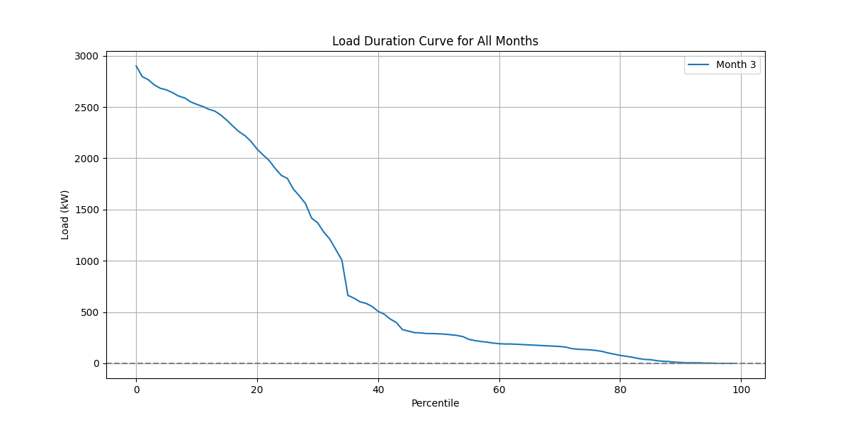

Image: load_duration_curve_weekdays_weekends.png

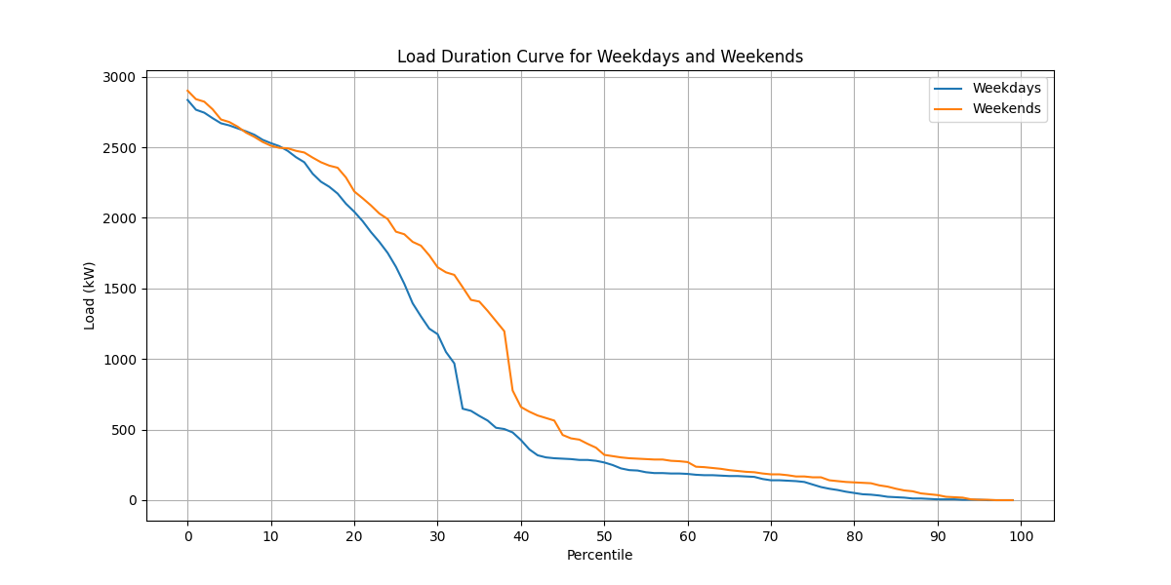

Image: load_pv(1,000_kWp).png

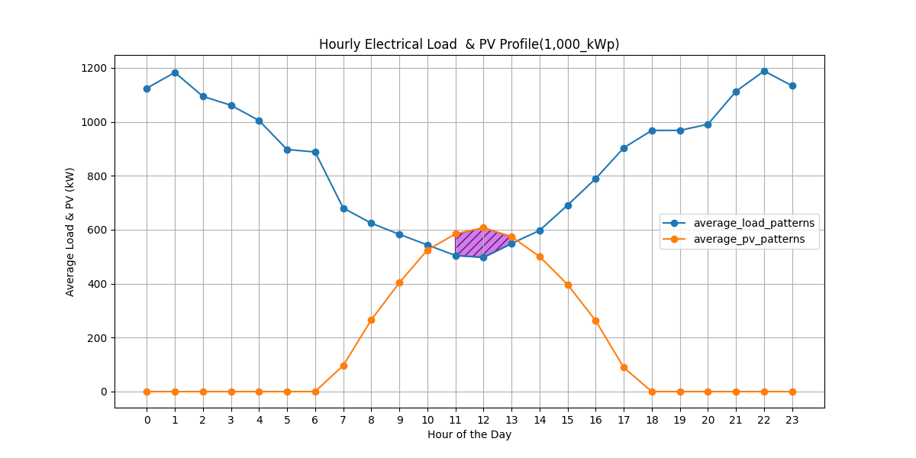

Image: load_pv(100_kWp).png

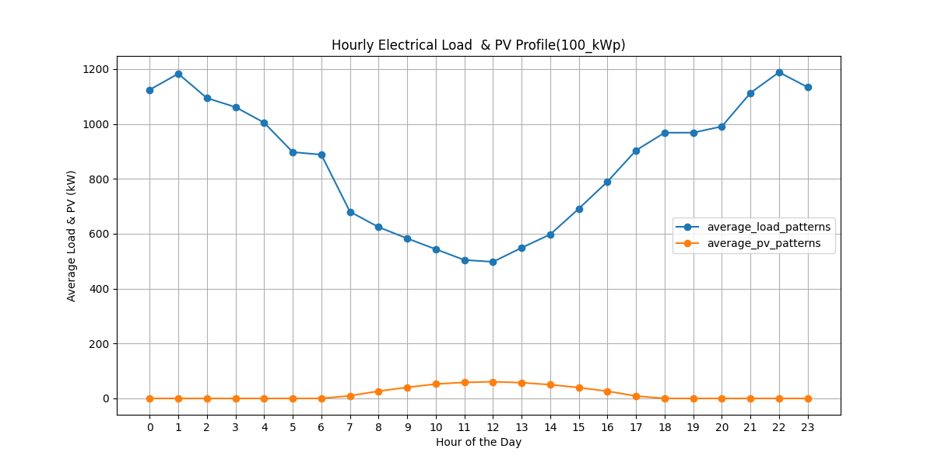

Image: load_pv(500_kWp).png

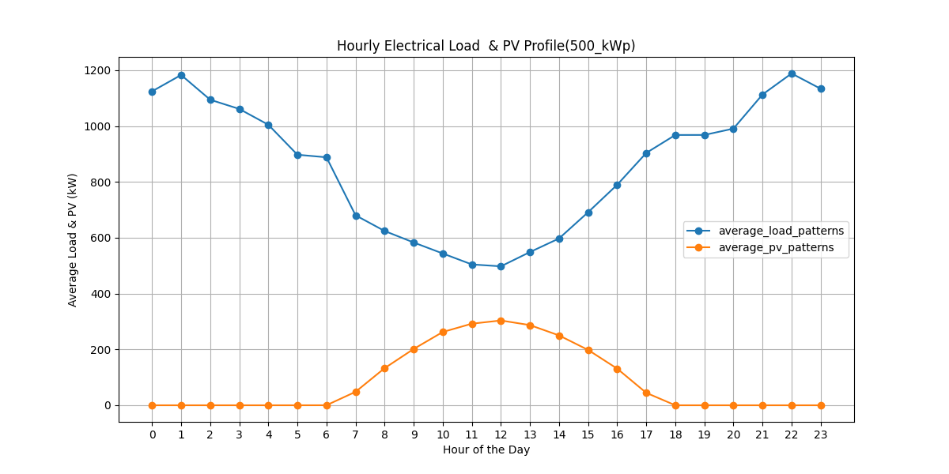

Image: peak_day.png

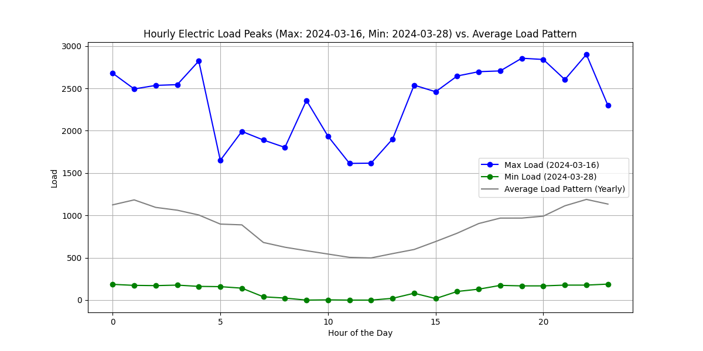

Image: pv curtailed 60 percentile 1,000 kWp.png

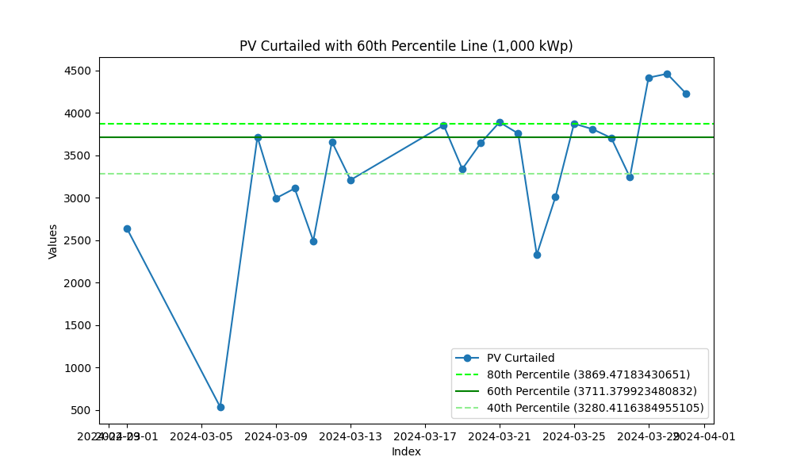

Image: pv curtailed 60 percentile 100 kWp.png

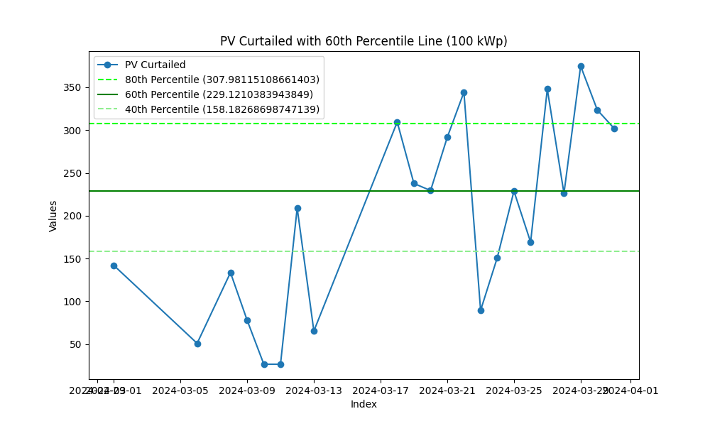

Image: pv curtailed 60 percentile 500 kWp.png

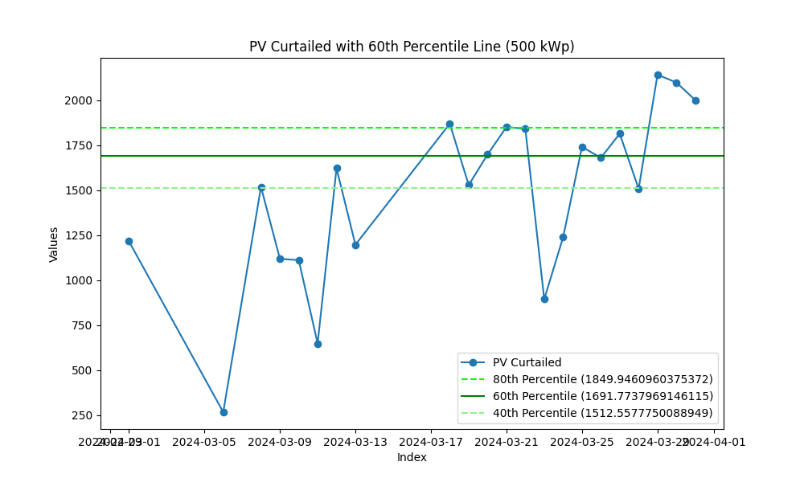

Image: Seasonal.png

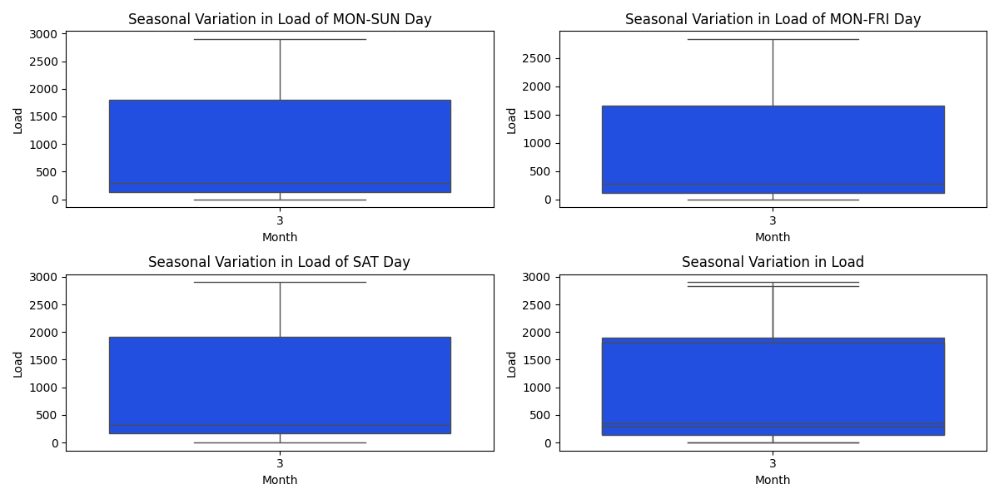

Image: Seasonal_comparison.png

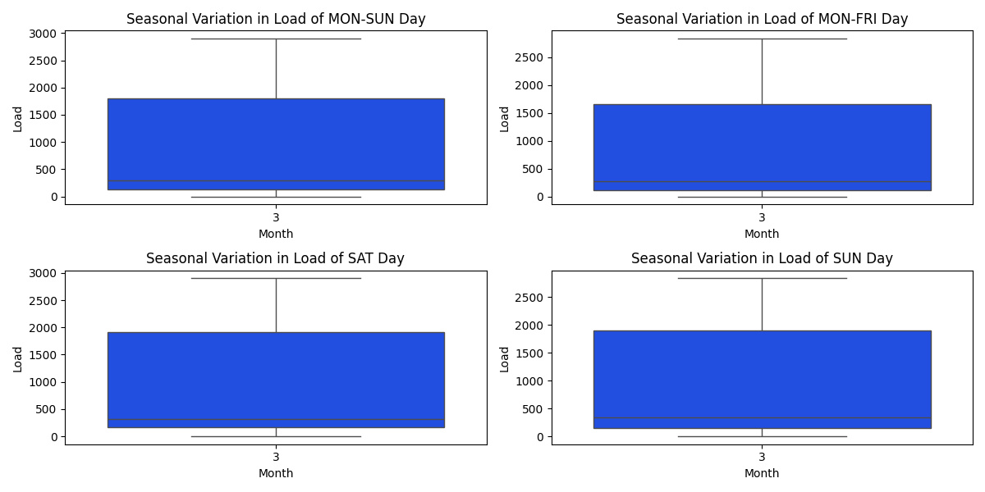

Image: Seasonal_specific_1.png

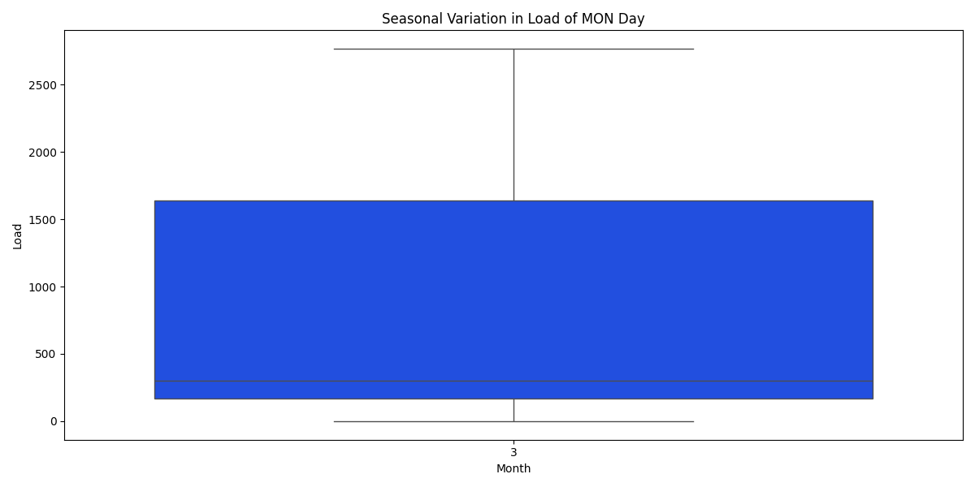

Image: Seasonal_specific_2.png

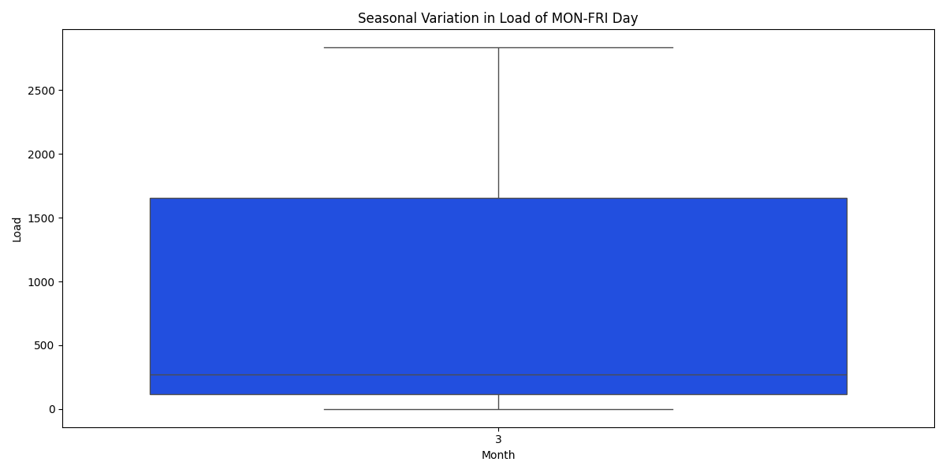

Image: Seasonal_specific_3.png

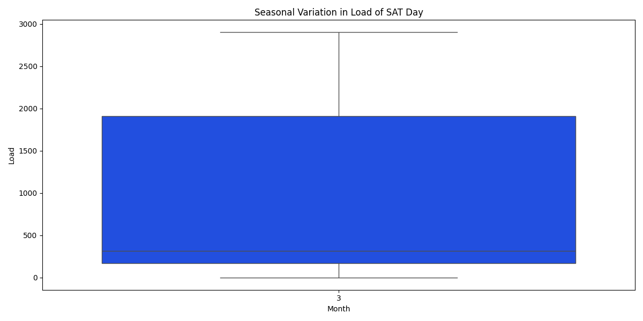

Image: Seasonal_specific_4.png

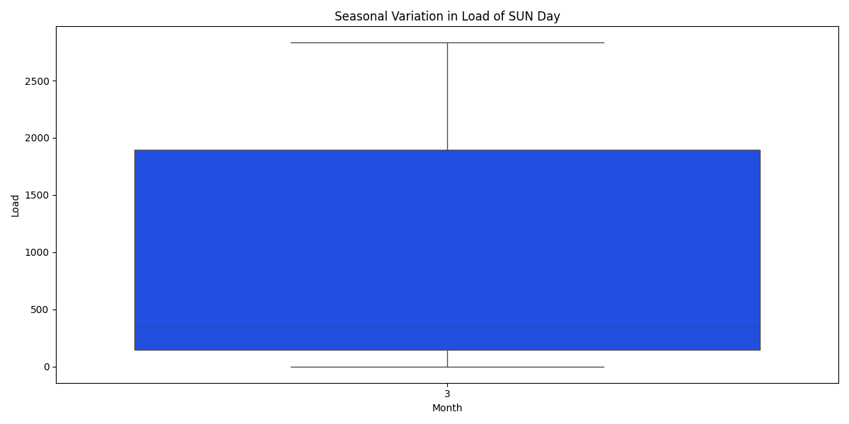

Image: Seasonal_specific_5.png

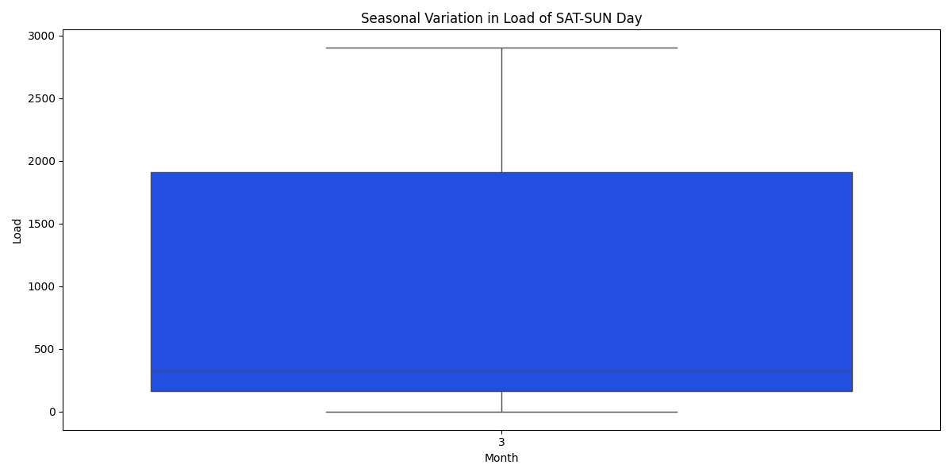

Energy consumption -- Load (kWh)  
1 January: 0 kWh, Load Factor: nan%  
2 February: 0 kWh, Load Factor: nan%  
3 March: 638,145 kWh, Load Factor: 29.6%  
4 April: 0 kWh, Load Factor: nan%  
5 May: 0 kWh, Load Factor: nan%  
6 June: 0 kWh, Load Factor: nan%  
7 July: 0 kWh, Load Factor: nan%  
8 August: 0 kWh, Load Factor: nan%  
9 September: 0 kWh, Load Factor: nan%  
10 October: 0 kWh, Load Factor: nan%  
11 November: 0 kWh, Load Factor: nan%  
12 December: 0 kWh, Load Factor: nan%  
  
  
  
Average load factor: nan %  
  
  
  
Energy of On Peak Data: 183,165.00 kWh  
Energy of Off Peak Data: 224,115.00 kWh  
Energy of holiday Data: 230,865.00 kWh  
Total Energy: 638,145.00 kWh  
Sum of all Data: 638,145.00 kWh  
Sum of demand_charge: 2,901.00 kW  
  
price_on_peak: 766,344.04 THB  
price_off_peak: 1,184,631.43 THB  
price_demand_charge: 385,629.93 THB  
Total Electricity Base Price: 2,340,352.28 THB  
 ignore FT & vat  
  
  
On-peak days: 11.4  
Off-peak days: 9.6  
Holiday days: 10.0  
 365 check -> 31.0  
  
  
  
  
PV Install_cap: 100.00 kW  
Energy of pv_produce: 13,349.30 kWh/year (Verify with PVSyst)  
 Monthly average PV energy production (kWh/month): nan,nan,18,nan,nan,nan,nan,nan,nan,nan,nan,nan  
Energy of pv_produce: 133.49 kWh/kWp/year  
Energy of pv_produce: 0.37 kWh/kWp/day  
Capacity Factor: 1.52 %  
Energy of pv_curtailed: 4,356.36 kWh (32.63 %)  
Energy of pv_serve_load: 8,992.94 kWh  
PR ratio (PV): 0.08  
PR ratio (Load): 0.05  
 pv_serve_load -- On Peak: 5,006.12 kWh  
 pv_serve_load -- Off Peak: 555.62 kWh  
 pv_serve_load -- holiday: 3,431.20 kWh  
 CO2 Emission Reduction: 4,065 kg-CO2  
Total Base Price: 43,740.10 THB  
 ignore FT & vat  
  
  
PV < load @9.00: 18 days  
PV > load (in that day): 17 days  
Cycle/year 369 cycles  
5000 Cycle = 13.6 year  
max battery from PV curtailed: 374.84 kWh  
 -- suggest Battery Capacity: 229 kWh  
  
  
 -- installed Battery : 900 kWh  
 -- suggest Battery Saving : 30,124 THB (335 THB/kWh/10years)  
 : 3,921 kWh (Curtail 32.63 % -> 3.26 %)  
  
 -- installed Battery : 500 kWh  
 -- suggest Battery Saving : 24,609 THB (492 THB/kWh/10years)  
 : 3,908 kWh (Curtail 32.63 % -> 3.36 %)  
  
 -- installed Battery : 400 kWh  
 -- suggest Battery Saving : 22,096 THB (552 THB/kWh/10years)  
 : 3,676 kWh (Curtail 32.63 % -> 5.10 %)  
  
 -- installed Battery : 300 kWh  
 -- suggest Battery Saving : 18,395 THB (613 THB/kWh/10years)  
 : 3,171 kWh (Curtail 32.63 % -> 8.88 %)  
  
 -- installed Battery : 250 kWh  
 -- suggest Battery Saving : 15,980 THB (639 THB/kWh/10years)  
 : 2,788 kWh (Curtail 32.63 % -> 11.75 %)  
  
 -- installed Battery : 200 kWh  
 -- suggest Battery Saving : 13,422 THB (671 THB/kWh/10years)  
 : 2,370 kWh (Curtail 32.63 % -> 14.88 %)  
  
 -- installed Battery : 150 kWh  
 -- suggest Battery Saving : 10,494 THB (700 THB/kWh/10years)  
 : 1,862 kWh (Curtail 32.63 % -> 18.68 %)  
  
 -- installed Battery : 100 kWh  
 -- suggest Battery Saving : 7,434 THB (743 THB/kWh/10years)  
 : 1,322 kWh (Curtail 32.63 % -> 22.73 %)  
  
  
  
  
  
PV Install_cap: 1000.00 kW  
Energy of pv_produce: 133,493.01 kWh/year (Verify with PVSyst)  
 Monthly average PV energy production (kWh/month): nan,nan,179,nan,nan,nan,nan,nan,nan,nan,nan,nan  
Energy of pv_produce: 133.49 kWh/kWp/year  
Energy of pv_produce: 0.37 kWh/kWp/day  
Capacity Factor: 1.52 %  
Energy of pv_curtailed: 73,913.92 kWh (55.37 %)  
Energy of pv_serve_load: 59,579.10 kWh  
PR ratio (PV): 0.08  
PR ratio (Load): 0.04  
 pv_serve_load -- On Peak: 31,675.78 kWh  
 pv_serve_load -- Off Peak: 4,023.42 kWh  
 pv_serve_load -- holiday: 23,879.90 kWh  
 CO2 Emission Reduction: 26,930 kg-CO2  
Total Base Price: 294,238.88 THB  
 ignore FT & vat  
  
  
PV < load @9.00: 10 days  
PV > load (in that day): 21 days  
Cycle/year 365 cycles  
5000 Cycle = 13.7 year  
max battery from PV curtailed: 4,460.38 kWh  
 -- suggest Battery Capacity: 3,711 kWh  
  
  
 -- installed Battery : 900 kWh  
 -- suggest Battery Saving : 64,027 THB (711 THB/kWh/10years)  
 : 12,763 kWh (Curtail 55.37 % -> 45.81 %)  
  
 -- installed Battery : 500 kWh  
 -- suggest Battery Saving : 35,804 THB (716 THB/kWh/10years)  
 : 7,148 kWh (Curtail 55.37 % -> 50.01 %)  
  
 -- installed Battery : 400 kWh  
 -- suggest Battery Saving : 28,643 THB (716 THB/kWh/10years)  
 : 5,718 kWh (Curtail 55.37 % -> 51.09 %)  
  
 -- installed Battery : 300 kWh  
 -- suggest Battery Saving : 21,482 THB (716 THB/kWh/10years)  
 : 4,289 kWh (Curtail 55.37 % -> 52.16 %)  
  
 -- installed Battery : 250 kWh  
 -- suggest Battery Saving : 17,902 THB (716 THB/kWh/10years)  
 : 3,574 kWh (Curtail 55.37 % -> 52.69 %)  
  
 -- installed Battery : 200 kWh  
 -- suggest Battery Saving : 14,322 THB (716 THB/kWh/10years)  
 : 2,859 kWh (Curtail 55.37 % -> 53.23 %)  
  
 -- installed Battery : 150 kWh  
 -- suggest Battery Saving : 10,741 THB (716 THB/kWh/10years)  
 : 2,144 kWh (Curtail 55.37 % -> 53.76 %)  
  
 -- installed Battery : 100 kWh  
 -- suggest Battery Saving : 7,161 THB (716 THB/kWh/10years)  
 : 1,430 kWh (Curtail 55.37 % -> 54.30 %)  
  
  
  
  
  
PV Install_cap: 500.00 kW  
Energy of pv_produce: 66,746.51 kWh/year (Verify with PVSyst)  
 Monthly average PV energy production (kWh/month): nan,nan,90,nan,nan,nan,nan,nan,nan,nan,nan,nan  
Energy of pv_produce: 133.49 kWh/kWp/year  
Energy of pv_produce: 0.37 kWh/kWp/day  
Capacity Factor: 1.52 %  
Energy of pv_curtailed: 32,615.57 kWh (48.86 %)  
Energy of pv_serve_load: 34,130.93 kWh  
PR ratio (PV): 0.08  
PR ratio (Load): 0.04  
 pv_serve_load -- On Peak: 18,247.78 kWh  
 pv_serve_load -- Off Peak: 2,340.66 kWh  
 pv_serve_load -- holiday: 13,542.50 kWh  
 CO2 Emission Reduction: 15,427 kg-CO2  
Total Base Price: 164,104.65 THB  
 ignore FT & vat  
  
  
PV < load @9.00: 13 days  
PV > load (in that day): 20 days  
Cycle/year 367 cycles  
5000 Cycle = 13.6 year  
max battery from PV curtailed: 2,142.82 kWh  
 -- suggest Battery Capacity: 1,692 kWh  
  
  
 -- installed Battery : 900 kWh  
 -- suggest Battery Saving : 63,447 THB (705 THB/kWh/10years)  
 : 12,519 kWh (Curtail 48.86 % -> 30.11 %)  
  
 -- installed Battery : 500 kWh  
 -- suggest Battery Saving : 35,875 THB (718 THB/kWh/10years)  
 : 7,063 kWh (Curtail 48.86 % -> 38.28 %)  
  
 -- installed Battery : 400 kWh  
 -- suggest Battery Saving : 28,981 THB (725 THB/kWh/10years)  
 : 5,698 kWh (Curtail 48.86 % -> 40.33 %)  
  
 -- installed Battery : 300 kWh  
 -- suggest Battery Saving : 21,903 THB (730 THB/kWh/10years)  
 : 4,289 kWh (Curtail 48.86 % -> 42.44 %)  
  
 -- installed Battery : 250 kWh  
 -- suggest Battery Saving : 18,322 THB (733 THB/kWh/10years)  
 : 3,574 kWh (Curtail 48.86 % -> 43.51 %)  
  
 -- installed Battery : 200 kWh  
 -- suggest Battery Saving : 14,687 THB (734 THB/kWh/10years)  
 : 2,859 kWh (Curtail 48.86 % -> 44.58 %)  
  
 -- installed Battery : 150 kWh  
 -- suggest Battery Saving : 11,041 THB (736 THB/kWh/10years)  
 : 2,144 kWh (Curtail 48.86 % -> 45.65 %)  
  
 -- installed Battery : 100 kWh  
 -- suggest Battery Saving : 7,396 THB (740 THB/kWh/10years)  
 : 1,430 kWh (Curtail 48.86 % -> 46.72 %)

## Images from EPC

Image: Annual Revenue and O&M Cost 100 kW.png

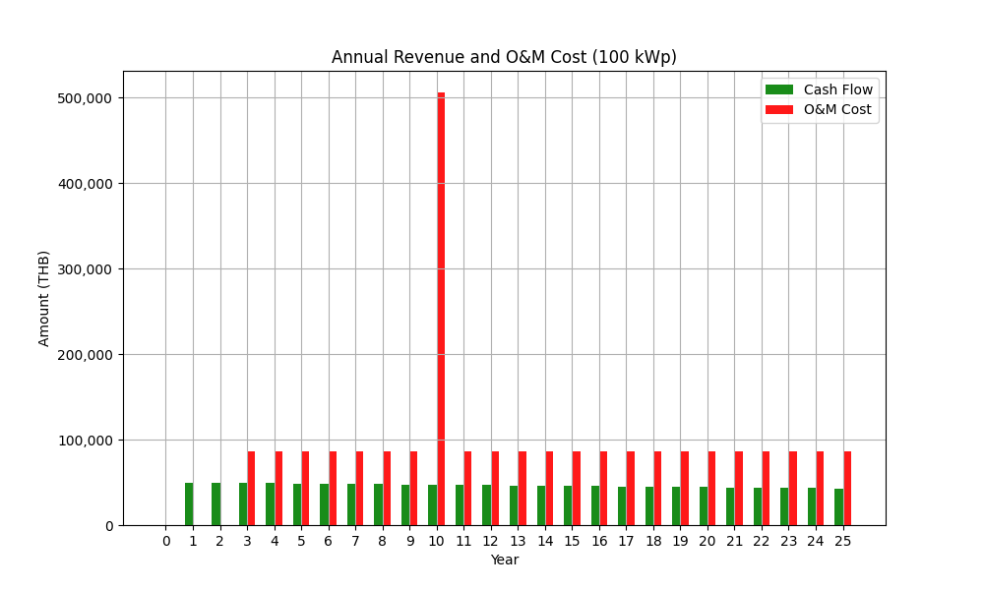

Assumption EPC:  
Tariff Rate Average (with VAT): 3.80000 THB/units  
  
Inputs Configuration:  
Project Time (Years): 25 years  
Cost per kW: 30000.0 THB/kW  
Margin: 10.0 %  
Sale Price per kW: 33000.00 THB/kW  
Solar Degradation First Year: 2.0 %  
Solar Degradation After First Year: 0.55 %  
Inverter Replacement Cost: 4200 THB/kW  
O&M Percentage: 2.5 %  
O&M Escalation Rate: 0.0 %  
O&M Starts at Year: 3  
  
EGAT Operation Cost:  
General Work Cost: 127000 THB  
Distance from EGAT HQ: 160 km  
EGAT Operation Cost: 131320 THB

## Images from GSA

Image: Electricity Cost Comparison 1,000kWp_15.0_15yr.png

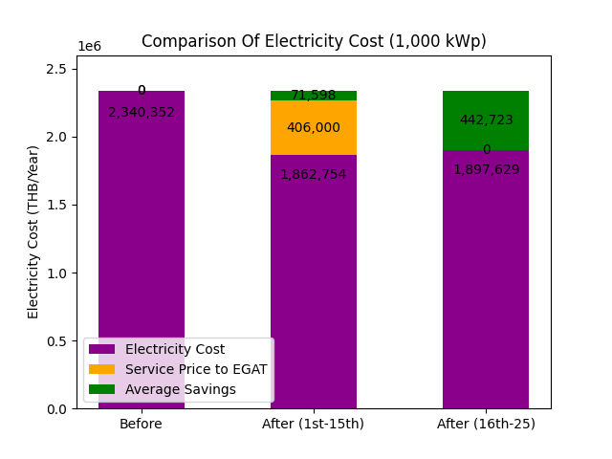

Image: Electricity Cost Comparison 100kWp_15.0_15yr.png

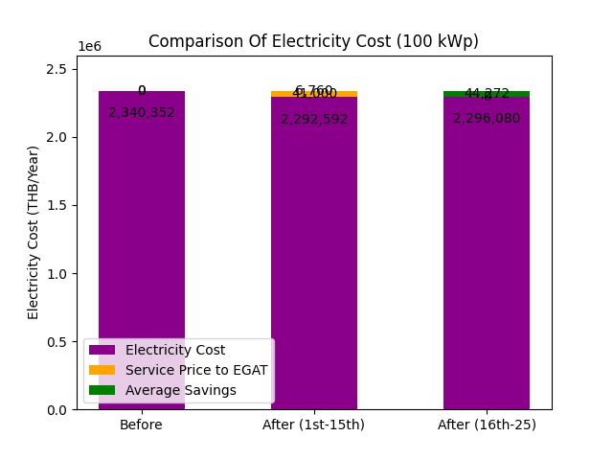

Image: Electricity Cost Comparison 500kWp_15.0_15yr.png

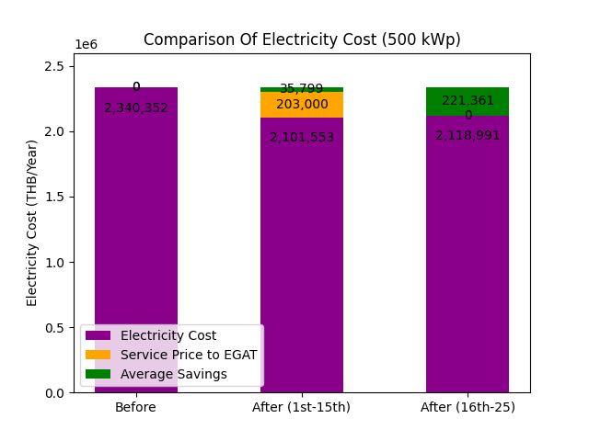

Image: Table image 1,000 kWp 15.0_15 yr.png

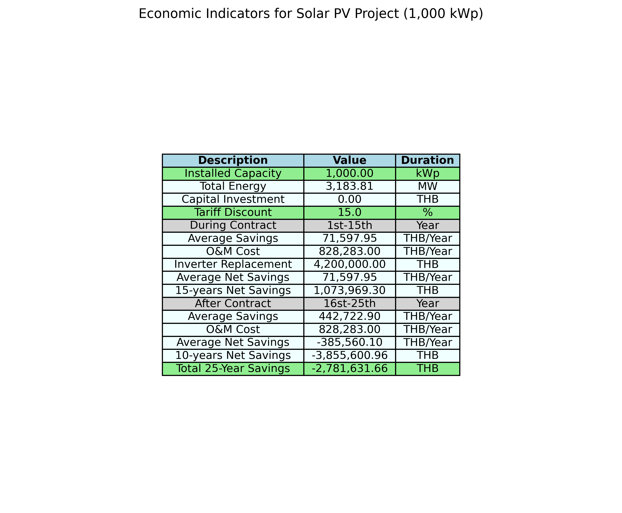

Image: Table image 100 kWp 15.0_15 yr.png

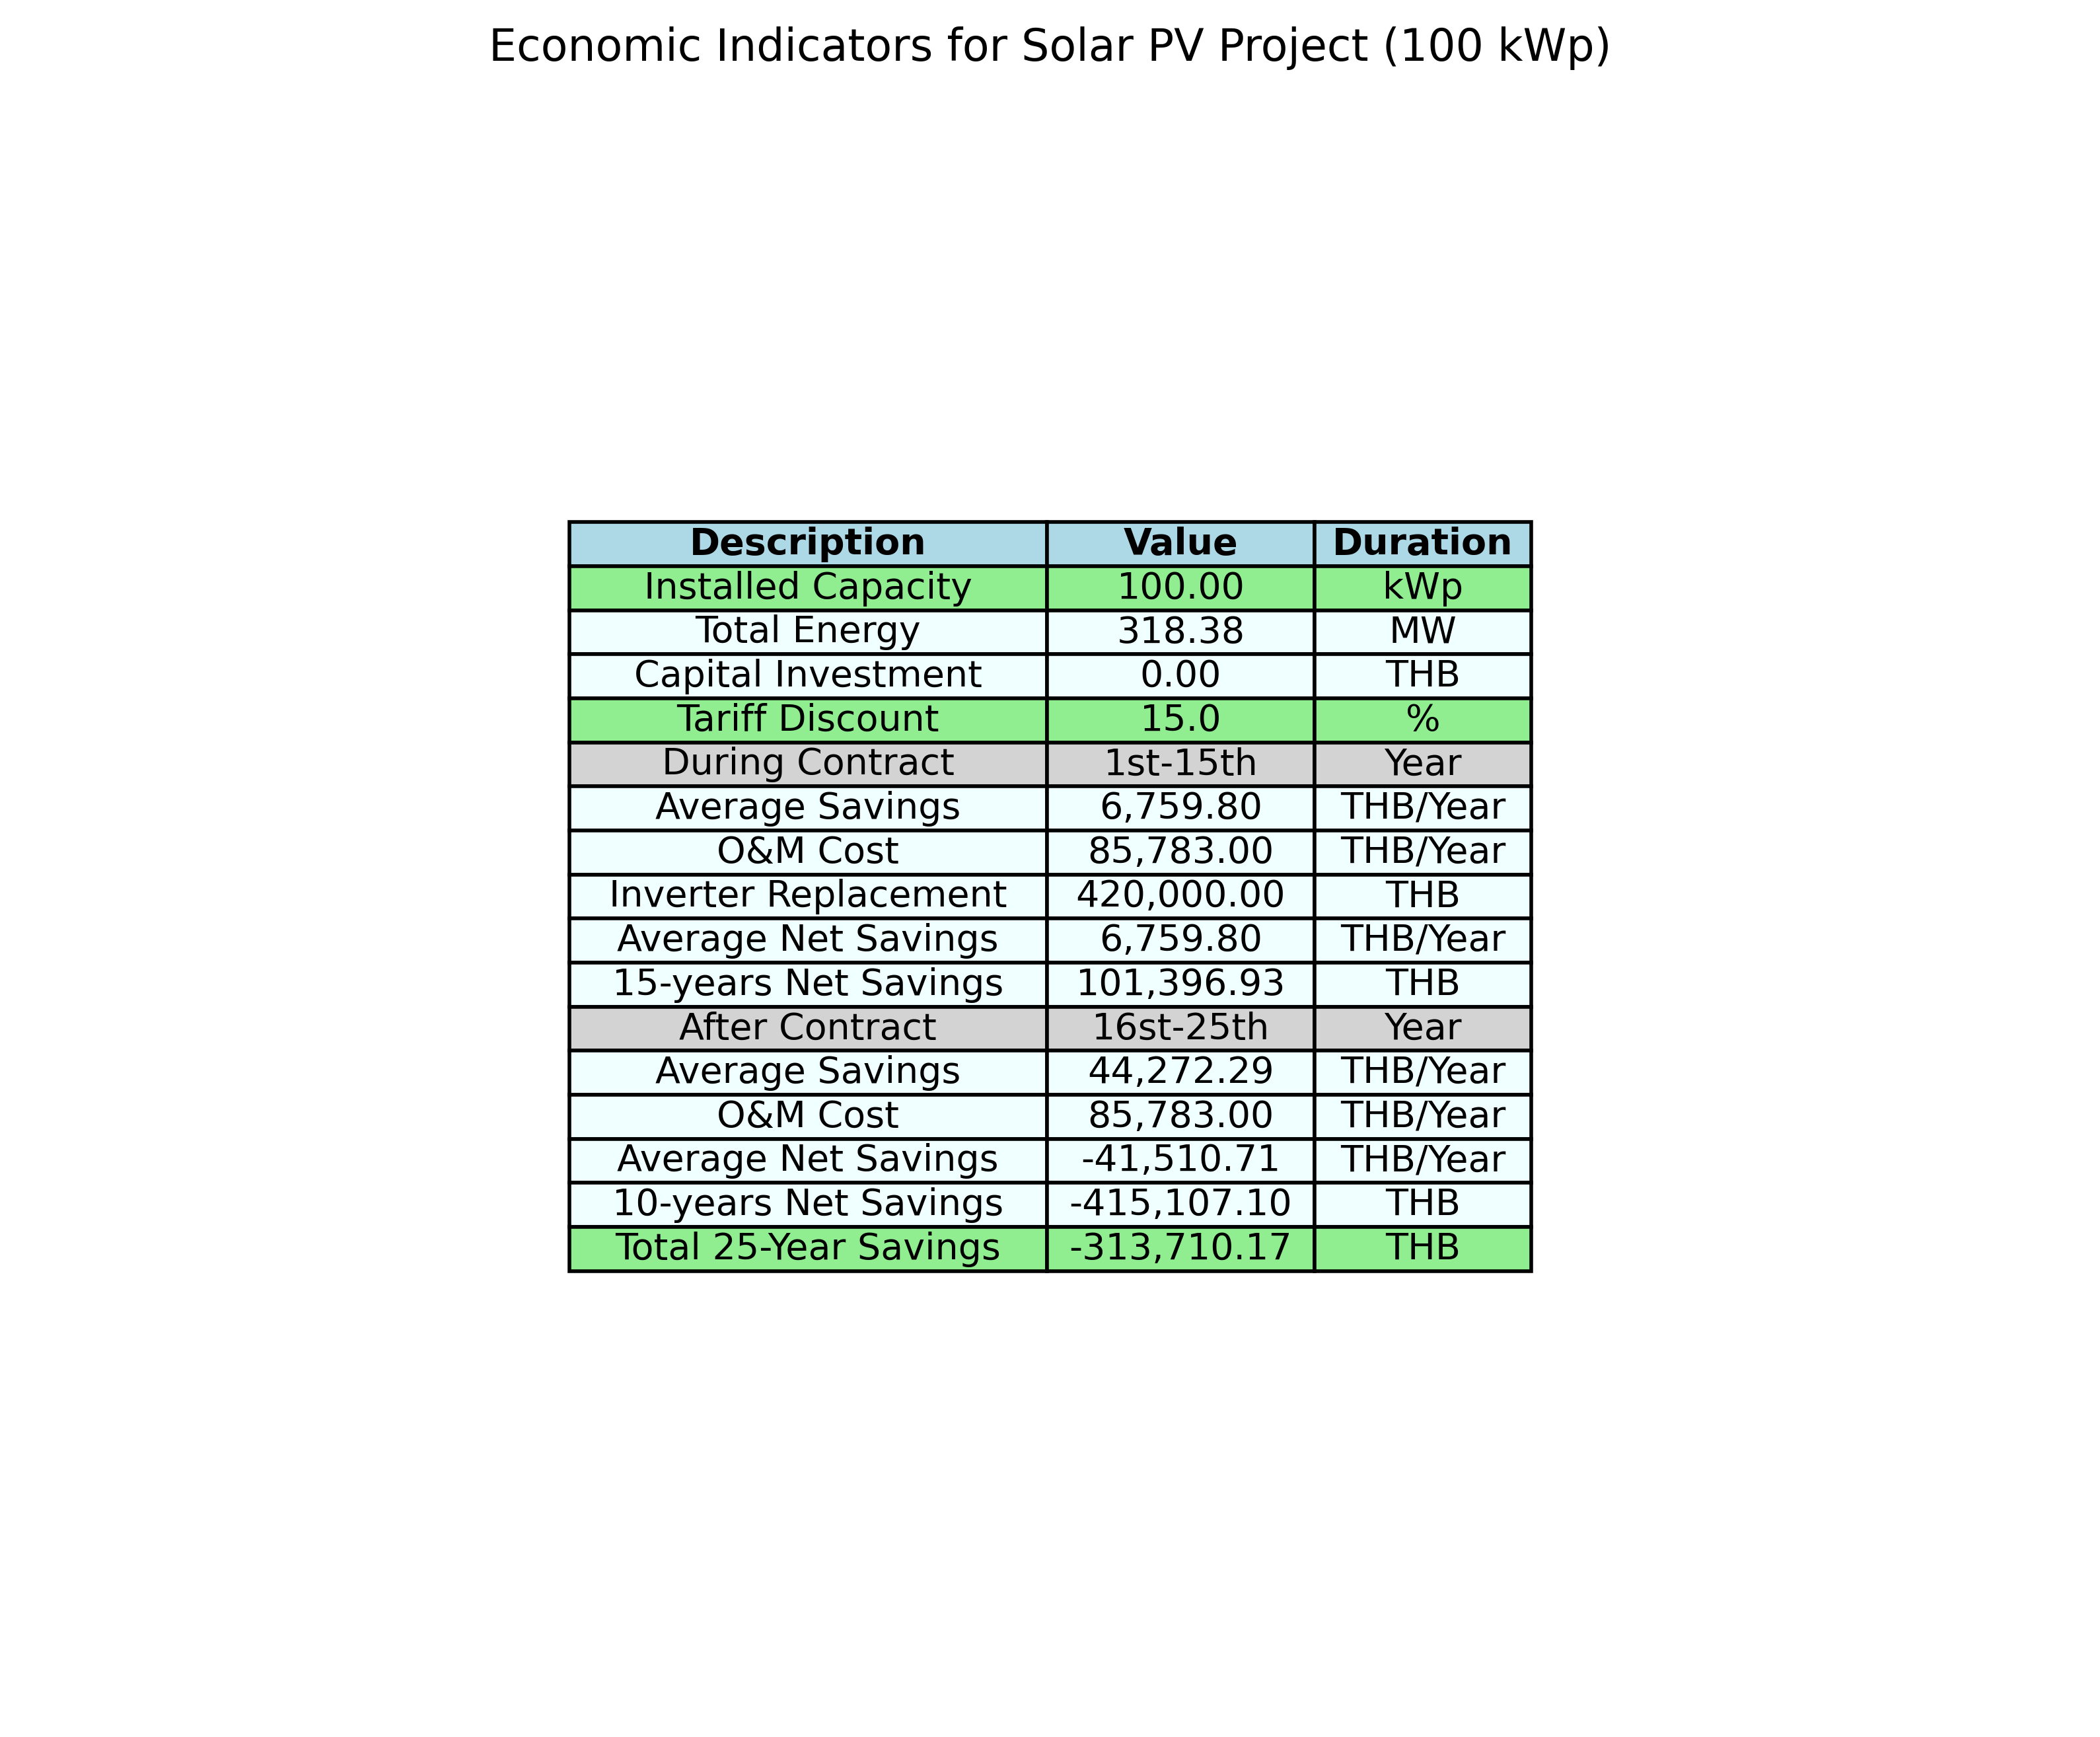

Image: Table image 500 kWp 15.0_15 yr.png

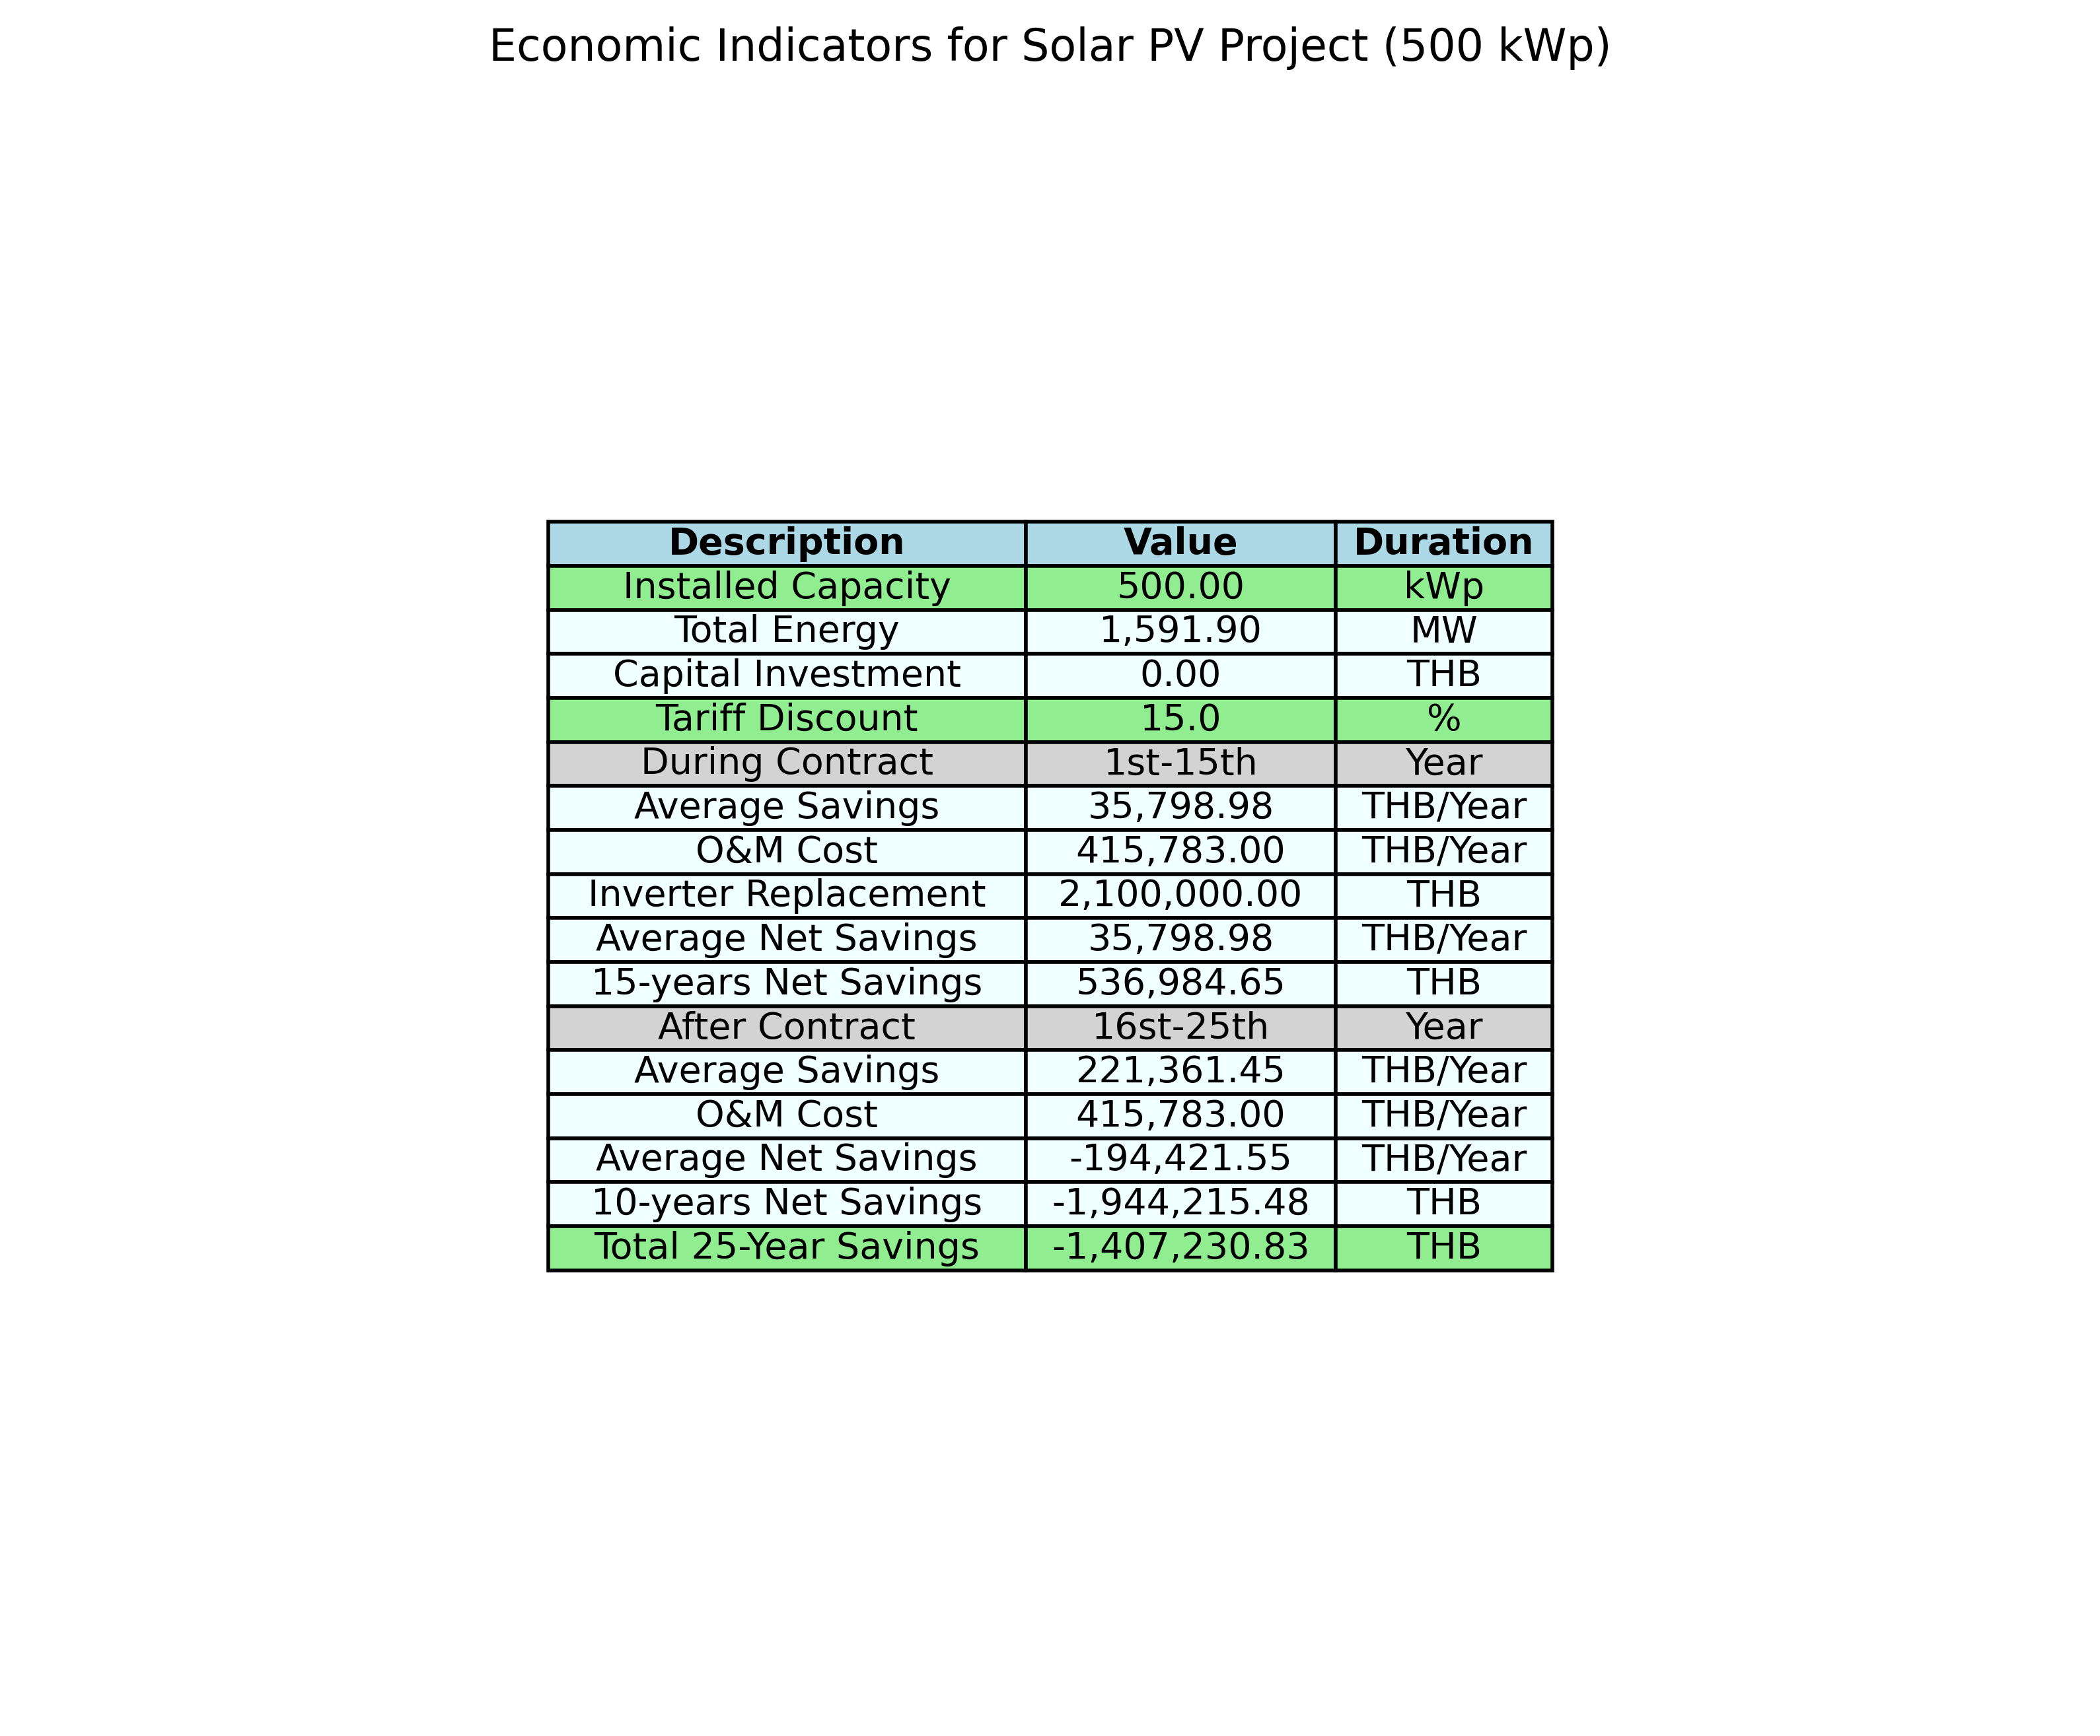

Assumption GSA:  
Tariff Rate Average (with VAT): 3.80000 THB/units  
  
Inputs Configuration:  
Project Time (Years): 25 years  
Cost per kW: 30000.0 THB/kW  
Margin: 10.0 %  
Sale Price per kW: 33000.00 THB/kW  
Solar Degradation First Year: 2.0 %  
Solar Degradation After First Year: 0.55 %  
Inverter Replacement Cost: 4200 THB/kW  
O&M Percentage: 2.5 %  
O&M Escalation Rate: 0.0 %  
O&M Starts at Year: 3  
  
tariff discount: 15.0 % (include FT, exclude VAT)  
contract year = 15 year  
  
EGAT Operation Cost:  
General Work Cost: 127000 THB  
Distance from EGAT HQ: 160 km  
EGAT Operation Cost: 131320 THB